AWS Certified Solution Architect Associate

US East (N. Virginia) is the oldest region and must of the services are firstly available in this region.

AWS Global Infrastructure

1. Availability Zone
2. Region
3. Edge Location

Note:

240 countries

200 Edge Locations

80 availability zone

25 regions

Data Center-> Collection of servers

## Availability Zone

* Consists of one or more physically separated data centers, each with redundant power, networking, and connectivity, housed in separate facilities.
* Characteristics of Availability Zone
  + They are physically separated
  + They use separate power grids
  + They are connected among themselves within a region through low-latency links
  + Fault tolerance- If one Availability zone gets out of service, other should not get impact
  + Allows for high availability
* An availability zone is associated with a single region
* Availability Zone contains server you are renting, and it is where you deploy your applications
* To coordinate Availability Zones across accounts, you must use the *AZ ID*, which is a unique and consistent identifier for an Availability Zone.
* An Availability Zone is represented by a region code followed by a letter identifier; for example, ***us-east-1a.***
* You can also use Elastic IP addresses to mask the failure of an instance in one Availability Zone by rapidly remapping the address to an instance in another Availability Zone.
* To ensure that resources are distributed across the Availability Zones for a region, AWS independently map Availability Zones to names for each AWS account. For example, the Availability Zone ***us-east-1a*** for your AWS account might not be the same location as us-east-1a for another AWS account.
* AZs are physically separated within a typical metropolitan region and are located in lower risk flood plains.
* AZs are all redundantly connected to multiple tier-1 transit providers.

## Region

* Physical location
* Collection of two or more availability zones
* When deploying your application, select region that is closest to users. It improves performance and availability
* Characteristics of Region
  + Fully independent and isolated- if one region gets impact, other will not be affected
  + Resource and service specific- resources are not automatically replicated across regions.
* You can replicate data within a region and between regions using private or public Internet connections.
* You retain complete control and ownership over the region in which your data is physically located, making it easy to meet regional compliance and data residency requirements.
* Note that there is a charge for data transfer between regions.
* When you launch an EC2 instance, you must select an AMI that’s in the same region. If the AMI is in another region, you can copy the AMI to the region you’re using.

## Edge Location

* Mini data center
* Cache content for faster delivery of content to users
* There are more edge locations than availability zones and regions
* It is not used to launch resources like EC2 instance. It is just used to cache content.
* Reduces latency and speeds up delivery of your application
* Related to Content Delivery Network (CDN) and Amazon CloudFront

IAM (Identity Access Management)

1. IAM offers following features
   1. Centralized control of your AWS account
   2. Shared access to your AWS account
   3. Granular permissions
   4. Identity Federation (including Active Directory, Facebook, LinkedIn, etc.)
   5. Multifactor Authentication
   6. Provide temporary access for users/devices and services where necessary
   7. Allows you to set up your own password rotation policy
   8. Integrates with many different AWS services
   9. Supports PCI DSS Compliance
2. New users have no permissions when first created
3. New users are assigned access key and secret access keys when first created
4. You only get to view the user’s password, access key ID and secret access key once. If you loose them, you have to regenerate them. So, save them in a secure location.

Billing Alarm

1. We can use CloudWatch Alarm to set Alarm whenever our bill goes above provided threshold.

Amazon S3

1. S3 is a universal namespace. That is, names must be unique globally.
2. This is because when a bucket is created, a web address is created. If a bucket is created in Northern Virginia (default region), it will create a web address <https://acloudguru.s3.amazonaws.com/>. If a bucket is created in Ireland, it will create a web address <https://acloudguru.eu-west-1.amaaonaws.com/>
3. Object consists of following:
   1. Key (name of the object/path)
   2. Value (data)
   3. Version ID (important for versioning)
   4. Metadata (data about data you are storing)
   5. Subresources
      1. Access Control Lists
      2. Torrent
4. Not suitable to install an operating system and databases on.

How does data consistency work for S3?

1. Read after Write consistency for PUTS of new objects
   1. This means if you write a new file and read it immediately afterwards, you will be able to view that data.
2. Eventual Consistency for overwrite PUTS and DELETES (can take some time to propagate)
   1. If you update an existing file or delete a file and read it immediately, you may get the older version, or you may not. Basically changes to objects can take a little bit of time to propagate.

S3 has following features

1. Tiered Storage Available
2. Lifecycle Management
3. Versioning
4. Encryption
5. MFA Delete: If you want to delete a file, multi factor authentication is required
6. Secure your data using Access Control Lists and Bucket Policies

S3 Charges

1. Storage
2. Request
3. Data Retrievals
4. Data transfer
5. Management and Replication
6. Transfer acceleration
7. Cross Region Replication Pricing

RRS (Reduce Redundancy Storage) -> S3 One Zone – IA

Restricting Bucket Access

1. Bucket Policies – applies across the whole bucket (bucket level)
2. Object Policies – applies to individual files
3. Access Control Lists – applies to individual objects
4. IAM Policies to Users and Groups – applies to users and groups

S3 Pricing Tiers

1. S3 Standard
2. S3 – IA
3. S3 – Intelligent Tiering
4. S3 One Zone – IA
5. S3 Glacier
6. S3 Glacier Deep Archive

S3 Encryption

It is possible to encrypt either individual object or encrypt objects at bucket level.

1. Encryption in Transit
   1. SSL/TLS
2. Encryption at rest (server side)
   1. S3 Managed Keys – SSE-S3 (amazon manages all the keys)
   2. AWS Key Management Service, Managed Keys – SSE-KMS
   3. Server Side Encryption with Customer Provided Keys – SSE-C
3. Client Side Encryption

Using Versioning with S3

1. Stores all versions of an object
2. Great backup tool
3. Once enabled, versioning cannot be disabled, only suspended
4. Integrates with lifecycle rules
5. It has MFA Delete capability, which uses multi-factor authentication, which can be used to provide additional layer of security

Note

1. Each version, if you want it to be public you have to specifically go in for each and every version and make it public.
2. Every time you make something public, even if latest version become public, it does not necessarily make the other versions public. You have to go in and do that individually.
3. If we delete individual versions, individual version of file will get deleted.
4. Deleting file itself will not actually delete file it will instead add a delete marker on top of objects.
5. On deleting delete marker, we will be able to access files.

Exam tips

1. Lifecycle Management can be used in conjunction with versioning.
2. Lifecycle Management can be applied to current versions and previous versions.

S3 Object Lock and Glacier Vault Lock

S3 Object Lock

1. You can use S3 Object Lock to store objects using a write once, read many (WORM) model.
2. Object locks can be on individual objects or applied across the bucket as a whole.
3. It can help you prevent objects from being deleted of modified for a fixed amount of time or indefinitely.
4. It comes in two different modes
   1. Governance Mode
      1. In this mode, users cannot overwrite or delete an object version or alter its lock settings unless they have special permissions.
      2. With this mode, you protect objects against being deleted by most users, but you can still grant some users permission to alter the retention settings or delete the object if necessary.
   2. Compliance mode
      1. In this mode, a protected object version cannot be overwritten or deleted by any user, including the root user in your AWS account.
      2. When an object is locked in compliance mode, its retention mode cannot be changed, and its retention period cannot be shortened.
      3. It ensures an object version cannot be overwritten or deleted for the duration of the retention period.

Retention Period

1. A retention period protects an object version for a fixed amount if time.
2. When you place a retention period on an object version, Amazon S3 stores a timestamp in the object version’s metadata to indicate when the retention period expires.
3. After the retention period expires, the object version can be overwritten or deleted unless you also placed a legal hold on the object version.

Legal holds

1. S3 Object Lock also enables you to place a legal hold on an object version.
2. Like a retention period, a legal hold prevents an object version from being overwritten or deleted.
3. However, a legal hold does not have an associated retention period and remain in effect until removed.
4. Legal holds can be freely placed and removed by any user who has the s3:PutObjectLegalHold permission.

Glacier Vault Lock

1. It allows you to easily deploy and enforce compliance controls for individual S3 Glacier vaults with a Vault Lock Policy.
2. You can specify controls such as WORM in a Vault Lock policy and lock the policy from future edits.
3. Once locked, the policy can no longer be changed.

S3 Prefixes

1. Prefix is the middle bit between the bucket name and the object.
2. Mybucketname/folder1/subfolder1/myfile.jpg -> /folder1/subfolder1

S3 Performance

1. Prefix
   1. S3 has extremely low latency. You can get the first byte out of S3 within 100-200 milliseconds.
   2. You can also achieve a high number of requests: 3,500 PUT/COPY/POST/DELETE and 5,500 GET/HEAD requests per second per prefix.
   3. So, we can get better performance by spreading reads across different prefixes. For sample, if you are using two prefixes, you can achieve 11,000 requests per second.
2. S3 Limitations when using KMS
   1. If you are using SSE-KMS to encrypt your objects in S3, you must keep in mind the KMS limit.
   2. When you upload a file, you will call GenerateDataKey in the KMS API.
   3. When you download a file, you will call Decrypt in the KMS API.
   4. KMS has certain number of limits. So uploading and downloading will count towards the KMS quota and quota is region specific. So, it depends on the region. However, it is either 5,500 requests per second, 10,000 requests per second or 30,000 requests per second depending on region and currently we cannot request a quota increase for KMS.
3. Multipart Uploads
   1. Recommended for files over 100 MB
   2. Required for files over 5 GB
   3. Parallelize uploads
4. S3 Byte-Range Fetches
   1. Parallelize downloads by specifying byte ranges
   2. Can be used to speed up downloads
   3. If there is a failure in the download, it is only for a specific byte range
   4. Can be used to just download partial amounts of file (e.g. Header information)

S3 Select

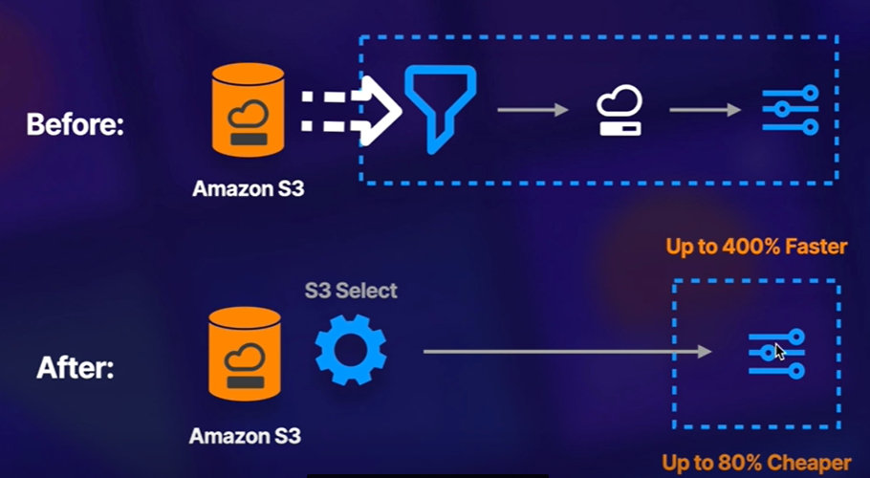

1. Enables applications to retrieve only a subset of data from an object by using simple SQL expressions.
2. Retrieve only data needed by your application
3. 400% performance increase
4. Get data by rows or columns using simple SQL expressions
5. Save money on data transfer and increase speed

Glacier Select

1. It allows you to run SQL queries against Glacier directly

AWS Organizations

1. Account management service that enables you to consolidate multiple accounts into an organization that you create and centrally manage.
2. We can also consolidate billing.
3. Paying account is independent and cannot access resources of other accounts.
4. All linked accounts are independent.

Advantages of Consolidated Billing

1. One bill per AWS account
2. Very easy to track charges and allocate costs
3. Volume pricing discount

S3 Cross Account Access

There are 3 different ways to share S3 buckets across accounts

1. Using Bucket Policies and IAM
   1. Applies across entire bucket
   2. Programmatic access only
2. Using Bucket ACLs and IAM
   1. Applies to individual objects
   2. Programmatic access only
3. Cross-account IAM Roles
   1. Programmatic and Console access

Cross Region Replication

1. Versioning must be enabled on both source and destination buckets.
2. Files in an existing bucket are not replicated automatically.
3. All subsequent updated files will be replicated automatically.
4. Deleting individual versions or delete markers will not be replicated.

S3 Transfer Acceleration

1. It makes use of CloudFront Edge Network to accelerate your uploads to S3.
2. Instead of uploading directly to your S3 bucket, you can use a distinct URL to upload directly to an edge location which will then transfer that files to S3.
3. You will get a distinct URL to upload to as:
   1. acloudguru.s3-accelerate.amazonaws.com

DataSync

1. used to move large amounts of data from on-premise to AWS
2. used with NFS and SMB compatible file systems.
3. Replication can be done hourly, daily or weekly.
4. Install the Data sync agent to start the replication
5. Can be used to replicate EFS to EFS. If this is the case, Datasync Agent is installed into EC2 instance that was connected to EFS.

CloudFront

1. Edge locations are not just READ only. You can write to them too.
2. Objects in Edge Location are cached for the life of TTL (Time to Live).
3. You can clear cached objects, but you will be charged. This is called invalidating the cache.
4. Origin
   1. This is the origin of the files that the CDN will distribute.
   2. This can be either an S3 Bucket, an EC2 Instance, an Elastic Load Balancer or Route53.
5. Distribution
   1. This is the name given to CDN which consists of a collection of Edge Locations.
   2. With CloudFront, you will get two different types of distribution
      1. Web distribution: typically used for websites
      2. RTMP: used for Media Streaming

CloudFront Signed URLs and Signed Cookies

1. Use signed URLs/Cookies when you want to secure content so that only the people you authorize are able to access it.
2. A signed URL is for individual files. 1 URL = 1 file
3. A signed cookie is for multiple files, 1 cookie = multiple files
4. When we create a signed URL or signed cookie, we attach a policy. The policy can include:
   1. URL expiration
   2. IP ranges
   3. Trusted signers (which AWS accounts can create signed URLs)
5. If your origin is EC2, then use CloudFront Signed URL. If your origin is S3, use S3 signed URL.

CloudFront Signed URL

1. Can have different origins. Does not have to be EC2. It can be S3, ELB.
2. Key-pair is account wide and managed by the root user
3. Can utilize caching features
4. Can filter by date, path, IP address, expiration, etc.

S3 Signed URL

1. Issues a request as the IAM user who creates pre-signed URL
2. You have all same permissions as the IAM user who has created that signed URL
3. Has a limited lifetime

Snowball

1. It can import to S3 and export from S3.

Storage Gateway

1. Virtual or physical device that is going to replicate your data into AWS
2. Service that connects an on-premises software appliance with cloud-software appliance with cloud-based storage to provide seamless and secure integration between an organization’s on-premises IT environment and AWS’s storage infrastructure.
3. The service allows you to securely store data to the AWS cloud for scalable and cost-effective storage.
4. Types of Storage Gateway
   1. File Gateway
      1. Way of connecting your on-premise infrastructure to S3
      2. Way of storing application server’s data into S3
      3. Using NFS and SMB
   2. Volume Gateway
      1. It is the way of storing copies of hard disk drives or virtual hard disk drives in S3
      2. Using iSCSI
      3. Types of Volume Gateway are
         1. Storage Volumes
            1. Entire dataset is stored on site and is asynchronously backed up to S3
            2. Lets you store your primary data locally, while asynchronously backing up that data to AWS
            3. This data is asynchronously backed up to Amazon S3 in the form of EBS Snapshots.
            4. Provides your on-premises applications with low-latency access to their entire datasets
         2. Cached Volumes
            1. Entire dataset is stored on S3 and the most frequently accessed data is cached on site
   3. Tape Gateway
      1. Used for backup and uses popular backup applications like NetBackup, Backup Exec, Veeam, etc

Athena

1. Serverless
2. Pay per query/per TB scanned
3. Helps you to analyze and query data located in S3 using standard SQL
4. Commonly used to analyze log data stored in S3

Macie

1. Uses machine learning to discover, classify and protect sensitive data stored in S3
2. Can also be used to analyze CloudTrail logs for suspicious API activity
3. Includes dashboards, reports and alerting
4. Great for PCI-DSS compliance and preventing ID theft

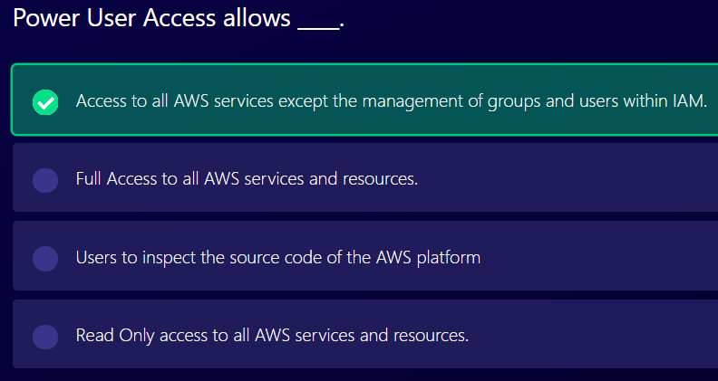

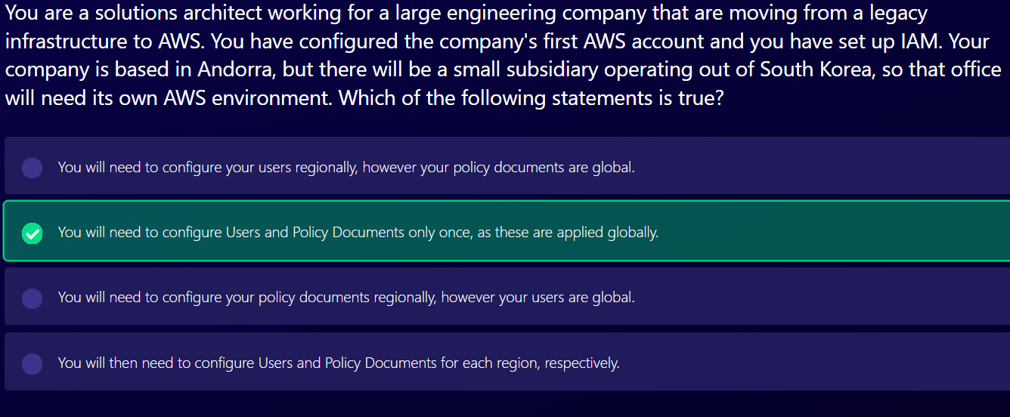

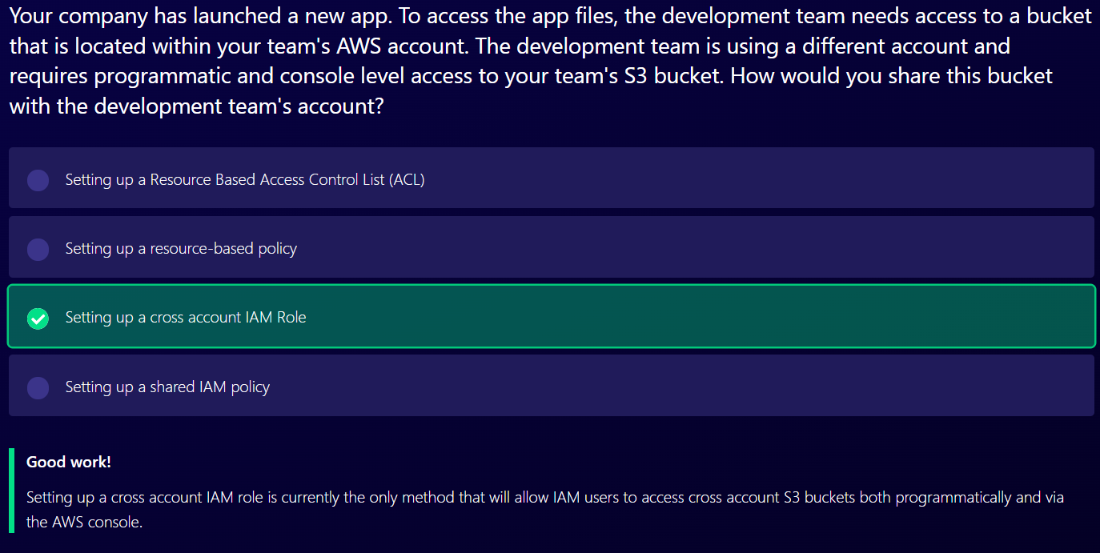

EC2 (Elastic Cloud Compute)

### Introduction

* Elastic Cloud Compute
* Virtual server in the cloud
* Allows you to rent and manage virtual servers in the cloud
* Has elastic compute power: It can grow and shrink based on load in your application
* Are not serverless
* You are able to provision an EC2 instance at the click of a button
* You can also use pre-configured template called AMI (Amazon Machine Image) to launch your resources.
* You will receive 750 compute hours per month on Free Tier Plan
* You can deploy your applications directly to EC2 instances.
* Amazon EC2 instances can run the Windows, Linux, or MacOS operating systems.
* **Integrated** – EC2 is integrated with most AWS services such as S3, RDS, and VPC to provide a complete, secure solution
* **Secure** – EC2 works in conjunction with VPC to provide a secure location

### EC2 Pricing Model

1. On demand
2. Spot
3. Reserved Instance
4. Dedicated Hosts
5. Savings Plans
6. On demand

* Fixed price in which you are billed based on instance type used
* You pay for what you use
* No contract
* Use on-demand instances when
  + You cannot make upfront payment or long-term commitment
  + Your applications have unpredictable workloads that cannot be interrupted
  + Your applications are under-development
  + Your applications will not run for more than a year

1. Spot

* Spot instance lets you take advantage of unused EC2 capacity
* Your request is available only if capacity is available
* Use Spot instance when
  + Your application is not concerned about start and stop time of execution
  + Your workload can be interrupted
  + Applications that are only feasible at very low compute prices.
  + Users with an urgent need for a large amount of additional compute capacity.
* You can save upto 90% off on-demand prices
* You pay for spot that is in effect at the beginning of each hour
* If Amazon terminate your instances you do not pay, if you terminate you pay for the hour.

1. Reserved Instance

* Allows you to commit to a specific instance type for 1 or 3 years
* Use reserved instance when
  + Applications with steady state or predictable usage
  + Your application has steady state usage and you can commit for 1 or 3 years
  + You can make upfront payment
  + Your application requires capacity reservation
* You can save upto 75% off on-demand prices using Standard Reserved Instance
* You are required to sign a contract of 1 or 3 years
* You can pay all-upfront, partial upfront or no upfront. All upfront for maximum term earns the highest discount
* Reserved Pricing Types
  + Standard RI provide upto 75% off on demand instances.
  + Convertible RIs provide up to 54% off on-demand price – provides the capability to change the attributes of the RI as long as the exchange results in the creation of RIs of equal or greater value.
  + Scheduled RIs are available to launch within the time window you reserve. With Scheduled Reserved Instances, you can reserve capacity that is scheduled to recur daily, weekly, or monthly, with a specified start time and duration, for a one-year term.

1. Dedicated Hosts

* Allows you to pay for physical server that is dedicated to running your instances. No other AWS customers is going to have applications running on this server. The server basically belongs to you
* Use dedicated hosts when
  + You want to bring your own server-bound software license from vendors like Microsoft and Oracle
  + You have regulatory or corporate compliance requirements around tenancy model
* You can save upto 70% off on-demand prices
* You can bring your existing per-core, per-socket and per-VM software licenses.
* Physical servers dedicated just for your use.
* You then have control over which instances are deployed on that host.
* Available as On-Demand or with Dedicated Host Reservation.
* Each dedicated host can only run one EC2 instance size and type.
* Most expensive option.
* Billing is per host.

1. Dedicated Instance

* Virtualized instances on hardware just for you.
* Also uses physically dedicated EC2 servers.
* Does not provide the additional visibility and controls of dedicated hosts (e.g. how instance are placed on a server).
* Billing is per instance.
* May share hardware with other non-dedicated instances in the same account.
* Available as On-Demand, Reserved Instances, and Spot Instances.
* Cost additional $2 per hour per region.

1. Savings Plan

* You do not commit for specific instance type instead you commit to compute usage (measured per hour) for 1 to 3 years
* Use savings plan when
  + You want to lower your bill across multiple compute services
  + You want flexibility to change compute services, instance types, OS or regions
* You can save upto 72% off on-demand prices
* Savings can be shared across various compute services like EC2, Fargate and lambda

EC2 Instance Types- Mnemonic

1. F – for FGPA
2. I – for IOPS
3. G – Graphics
4. H – High Disk Throughput
5. T – Cheap general purpose
6. D – Density
7. R – for RAM
8. M – main choice for general purpose apps
9. C – Compute
10. P – Graphics
11. X – Extreme Memory
12. Z – Extreme memory and CPU
13. A – Arm-based workloads
14. U – Bare Metal

Security Group

1. All inbound traffic is blocked by default.
2. All outbound traffic is allowed.
3. Changes to security groups take effect immediately.
4. You can have any number of EC2 instances within a security group.
5. You can have multiple security groups attached to EC2 instances.
6. There is no one-to-one relationship between EC2 instance and security group.
7. Security groups are stateful.
8. If you create an inbound rule allowing traffic in, that traffic is automatically allowed back out again.
9. You cannot block specific IP addresses using Security Groups, instead use Network Access Control Lists.
10. You can specify allow rules, but not deny rules.

EBS (Elastic Block Storage)

1. Virtual hard disk drive in the cloud
2. Provides persistent block storage volumes
3. EBS Volume will always be in same AZ as EC2 Instance
4. You can change EBS volume size on the fly, including changing the size and storage type.
5. Amazon EBS Volume is automatically replicated within its AZ to protect you from component failure, offering high availability and durability.
6. Types of EBS Storage

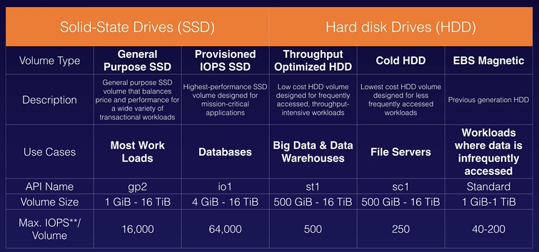

* 1. General Purpose (SSD)
  2. Provisioned IOPS (SSD)
  3. Throughput Optimized Hard Disk Drive
  4. Cold Hard Disk Drive
  5. Magnetic

EBS Snapshot

1. Snapshots exist on S3.
2. Snapshots are point in time copies of volumes.
3. Snapshots are incremental – this means that only the blocks that have changed since your last snapshot are moved to S3.
4. If this is your first snapshot, it may take some time to create.
5. To create a snapshot for Amazon EBS volumes that serve as root devices, you should stop the instance before taking the snapshot.
6. However you can take a snap while the instance is running.
7. You can create AMI’s from snapshot.

To move EC2 volume

1. To migrate EC2 volumes from one AZ to another, take a snapshot of it, create an AMI from the snapshot and then use the AMI to launch the EC2 instance in a new AZ.
2. To move an EC2 volume from one region to another, take a snapshot of it, create an AMI from the snapshot and then copy the AMI from one region to the other. Then use the copied AMI to launch the new EC2 instance in the new region.

AMI

1. You can select AMI based on
   1. Region
   2. Operating System
   3. Architecture (32-bit or 64-bit)
   4. Launch Permissions
   5. Storage for the root device
      1. Instance store
      2. EBS Backed Volumes
2. All AMIs are categorized as either backed by Amazon EBS or backed by Instance Store.
3. For EBS Volumes: the root device for an instance launched from the AMI is an Amazon EBS volume created from an Amazon EBS snapshot.
4. For Instance Store Volumes: The root device for an instance launched from the AMI is an Instance Store volume created from a template stored in Amazon S3.

EBS vs Instance Store

1. Instance Store volumes cannot be stored. If the underlying host fails, you will lose your data.
2. EBS backed instances can be stopped. You will not lose the data on this instance if it is stopped.
3. You can reboot both, you will not lose your data.
4. By default, both root volumes will be deleted on termination. However, with EBS volumes, you can tell AWS to keep the root device volume.

ENI vs ENA vs EFA

1. ENI
   1. Elastic Network Interface
   2. Virtual network card on your EC2 instance
   3. When an EC2 instance is launched, it is going to have a ENI attached to it automatically and then you can add additional ones.
   4. It allows a primary private IPv4 address from the IPv4 address range of your VPC
   5. It allows one or more secondary private IPv4 addresses from the IPv4 address range of your VPC
   6. With an ENI, you get
      1. one elastic IP address per private IPv4 address
      2. one or more IPv6 addresses
      3. one or more security groups
      4. A MAC address
      5. A source/destination check flag
      6. A description of what the ENI is
   7. When to use ENI?
      1. Create a management network
      2. You can have an additional ENI of you are using network and security appliances in your VPC
      3. Create dual-homed instances with workloads/roles on distinct subnets
      4. Create a low-budget, high availability solution
2. EN
   1. Enhanced networking
   2. Used where you want good network performance
   3. Uses single root I/O virtualization (SR-IOV) to provide high-performance networking capabilities on supported instance types.
   4. It provides higher I/O performance and lower CPU utilization when compared to traditional virtualized network interfaces
   5. Provides higher bandwidth, higher packet per second (PPS) performance, and consistently lower inter-instance latencies.
   6. There is no additional charge for using enhanced networking.
   7. Depending on your instance type, enhanced networking can be enabled using two methodologies
      1. Elastic Network Adapter (ENA): which supports network speeds of up to 100 Gbps for supported instance types
      2. Intel 82599 Virtual Function (VF) interface: which supports network speeds of up to 10 Gbps for supported instance types
3. Elastic Fabric Adapter
   1. A network device that you can attach to your Amazon EC2 instance to accelerate High Performance Computing (HPC) and machine learning applications.
   2. EFA provides lower and more consistent latency and higher throughout than the TCP transport traditionally used in cloud-based HPC systems.
   3. EFA can use OS-bypass. OS-bypass enables HPC and machine learning applications to bypass the operating system kernel and to communicate directly with the EFA device. It makes it a lot faster with a lot lower latency.
   4. Not supported with Windows currently, only Linux.

Encrypted Root Device Volumes and Snapshots

1. Snapshots of encrypted volumes are encrypted automatically.
2. Volumes restored from encrypted snapshots are encrypted automatically.
3. You can share snapshots, but only if they are unencrypted. These snapshots can be shared with other AWS accounts or made public.
4. You can now encrypt root device volumes upon creation of the EC2 instance.

To create encrypted volume from unencrypted volume

1. Create a Snapshot of the unencrypted root device volume
2. Create a copy of the Snapshot and select the encrypt option
3. Create an AMI from the encrypted Snapshot
4. Use that AMI to launch new encrypted instances

Spot Price

1. To use Spot instances, you must first decide on your maximum Spot price. The instance will be provisioned so long as the Spot price is BELOW your maximum Spot price.
2. The hourly Spot price varies depending on capacity and region.
3. If the Spot price goes above your maximum, you have two minutes to choose whether to stop or terminate your instance.
4. You may also use a Spot block to stop your Spot Instances from being terminated even if the Spot price goes over your max Spot price. You can set Spot block for between one to six hours currently.

Spot Instances are not good for:

1. Persistent workloads
2. Critical jobs
3. Databases

How to terminate Spot Instances

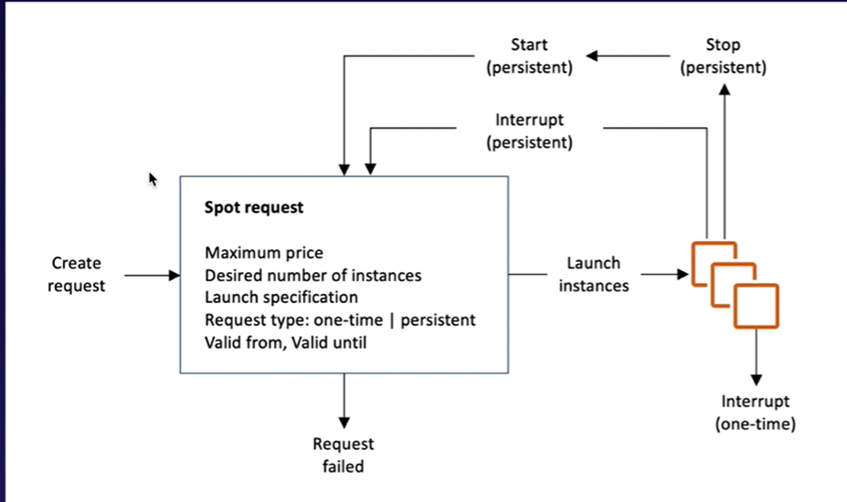

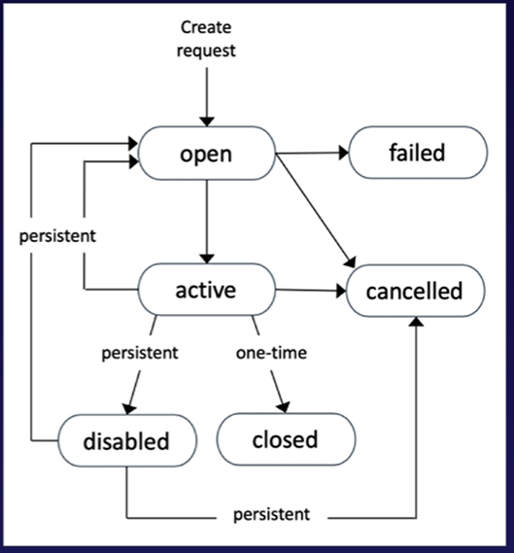

1. First of all, we need to create a request. Spot Request will contain Maximum price, Desired number of instances, Launch Specification, Request type (one-time/persistent), Valid from and Valid until.
2. If the request is one time, request will be fulfilled once the spot price is below maximum price and then once the spot price goes above your maximum price, your instances will be terminated and you won’t have any more instances.
3. But if the request is persistent, it will launch your instances and then once your spot price goes above your maximum price, those instances will be stopped and as soon as the spot price goes below your maximum price, it is going to relaunch those instances. i.e. If the request is persistent, it is going to go throughout this cycle.

Spot Fleets

1. A spot fleet is a collection of Spot Instances and optionally, on-demand instances.
2. It attempts to launch the number of Spot Instances and On-demand Instances to meet the target capacity you specified in the Spot fleet request.
3. The request for Spot Instances is fulfilled if there is available capacity and the maximum price you specified in the request exceeds the current Spot price.
4. Spot fleet attempts to maintain its target capacity fleet of your Spot Instances are interrupted.
5. Spot fleet will try and match the target capacity with your price restraints.
6. You can have the following strategies with Spot Fleets
   1. capcityOptimized
      1. spot instances will come from the pool with optimal capacity.
   2. Diversified
      1. The spot instances are diversified across all pools.
   3. lowestPrice
      1. this is the default strategy.
      2. Spot instances will come from the pool with the lowest price.
   4. InstancePoolsToUseCount
      1. Spot instances are distributed across the number of Spot Instance pools you specify.

When we start our EC2 instance, the following happens:

1. Operating system boots up
2. User data script is run (bootstrap scripts)
3. Applications start (can take some time)

EC2 Hibernate

1. If the EC2 Instance is topped, the data is kept on the disk (with EBS) and will remain on the disk until the EC2 instance is started.
2. If the instance is terminated, then by default the root device volume will also be terminated.
3. If the instance is hibernated, the operating system is told to perform hibernation (suspend-to-disk). Hibernation saves the content from the instance memory (RAM) to your Amazon EBS root volume.
4. When you start your instance out of hibernation:
   1. The Amazon EBS root volume is restored to its previous state
   2. The RAM contents are reloaded
   3. The processes that were previously running on the instance are resumed
   4. Previously attached data volumes are reattached and the instance retains its instance ID
5. With EC2 Hibernate, the instance boots much faster. The operating system does not need to reboot because the in-memory state (RAM) is preserved. This is useful for:
   1. Long running processes
   2. Services that take time to initialize
6. To enable hibernation, root volume must be encrypted.
7. EC2 Hibernate preserves the in-memory RAM on persistent storage (EBS)
8. Much faster to boot up because you do not need to reload the operating system
9. Instance RAM must be less than 150 GB
10. Instance families include C3, C4, C5, M3, M4, M5, R3, R4 and R5
11. Available for Windows, Amazon Linux 2 AMI and Ubuntu
12. Instances cannot be hibernated for more than 60 days
13. Available for On-demand Instances and Reserved Instances

CloudWatch

1. CloudWatch can monitor things like:
   1. Compute
   2. Storage and Content Delivery
2. Host level metrics consist of:
   1. CPU
   2. Network
   3. Disk
   4. Status check

CloudWatch monitors performance.

CloudTrail monitors API calls in the AWS platform.

To view user data

Use command: curl <http://169.254.169.254/latest/user-data>

To view meta-data

Use command: curl <http://169.254.169.254/latest/meta-data/\>

EFS

In EFS, in terms of consistency, it is always Read After Write Consistency

EC2 Placement Groups

1. There are three types of EC2 Placement Groups
   1. Clustered Placement Group
      1. It is a grouping of instances within a single AZ.
      2. Recommended for applications that need low network latency, high network throughput or both.
      3. It cannot span multiple AZ.
   2. Spread Placement Group
      1. Group of instances that are each placed on distinct underlying hardware.
      2. Instances will be in separate racks so each of them have different network and power source.
      3. Recommended for applications that have a small number of critical instances that should be kept separate from each other.
      4. Can be in different AZ within one region
      5. It can span multiple AZ
   3. Partitioned Placement Group
      1. Amazon EC2 divides each group into logical segments called partitions.
      2. Amazon EC2 ensures that each partition within a placement group has its own set of racks.
      3. Each rack has its own network and power source.
      4. No two partitions within a placement group share the same racks allowing you to isolate the impact of hardware failure within your application.
      5. Use case can be HDFS, HBase and Cassandra
      6. It can span multiple AZ
2. The name you specify for a placement group must be unique within your AWS account.
3. Only certain types of instances can be launched in a placement group (Comput Optimized, GPU, Memory Optimized, Storage Optimized)
4. AWS recommend homogenous instances within clustered placement groups.
5. You cannot merge placement groups.
6. You can move an existing instance into a placement group. Before you move the instance, the instance must be in the stopped state. You can move or remove an instance using the AWS CLI or AWS SDK, you cannot do it via the console yet.

HPC on AWS

1. HPC can be achieved on AWS through
   1. Data transfer
   2. Compute and networking
   3. Storage
   4. Orchestration and automation
2. Data transfer services that allow us to achieve HPC on AWS are:
   1. Snowball, Snowmobile (TB/PB worth of data)
   2. AWS DataSync to store on S3, EFS, FSx for Windows, etc
   3. Direct Connect
3. Compute and networking services that allow us to achieve HPC on AWS are:
   1. EC2 instances that are GPU or CPU optimized
   2. EC2 fleets (Spot instances or Spot fleets)
   3. Placement Groups (cluster placement groups)
   4. Enhanced Networking
   5. Elastic Network Adapters
   6. Elastic Fabric Adapters
4. Storage services that allow us to achieve HPC on AWS are:
   1. Instance-attached storage
      1. EBS: Scale up to 64,000 IOPS with Provisioned IOPS (PIOPS)
      2. Instance Store: scale to millions of IOPS, low latency
   2. Network storage
      1. Amazon S3: Distributed object-based storage
      2. Amazon EFS: Scale IOPS based on total size, or use Provisioned IOPS
      3. Amazon FSx for Lustre: HPC-optimized distributed file system; millions of IOPS; which is also backed by S3
5. Orchestration and automation services that allow us to achieve HPC on AWS are:
   1. AWS Batch
      1. Allows to run hundreds of thousands of batch computing jobs on AWS
      2. Allows you to run a single job that spans multiple EC2 instances
   2. AWS ParallelCluster
      1. Open-source cluster management tool that makes it easy for you to deploy and manage HPC clusters on AWS
      2. Uses single text file to model and provision all the resources needed for your HPC applications in an automated and secure manner
      3. Automate creation of VPC, subnet, cluster type and instance types

AWS WAF

1. Web application firewall that lets you monitor the HTTP and HTTPS requests that are forwarded to Amazon CloudFront, Application Load Balancer or API Gateway
2. Lets you control access to your content
3. You can configure conditions such as what IP addresses are allowed to make this request or what query string parameters need to be passed for the request to be allowed. Then the application load balancer or CloudFront or API Gateway will either allow this content to be received or to give a HTTP 403 status code.
4. AWS WAF allows 3 different behaviors:
   1. Allows all requests except the ones you specify
   2. Block all requests except the ones you specify
   3. Count the requests that match the properties you specify

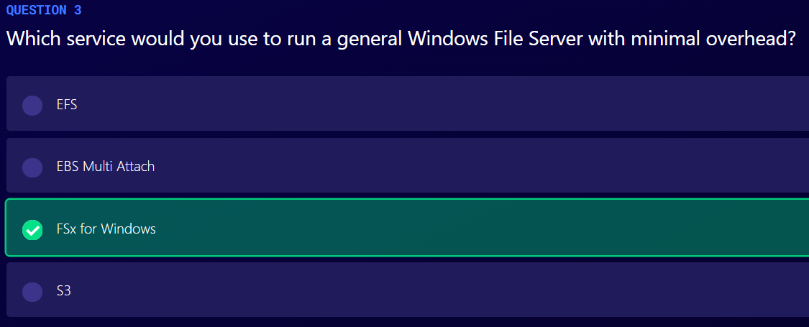

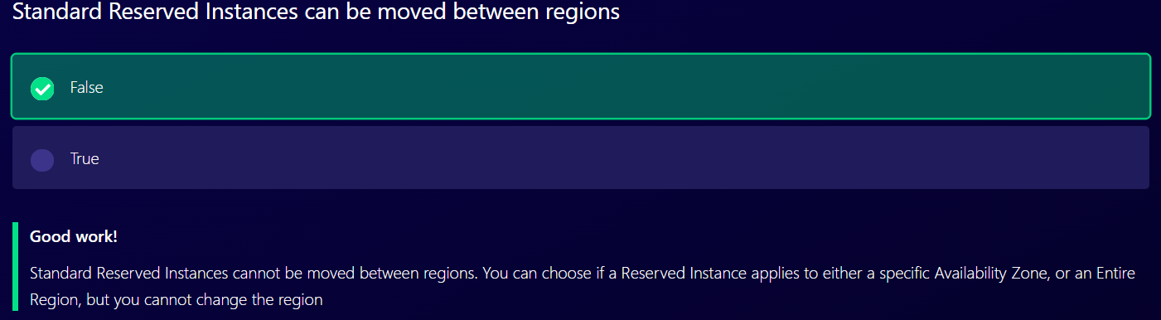

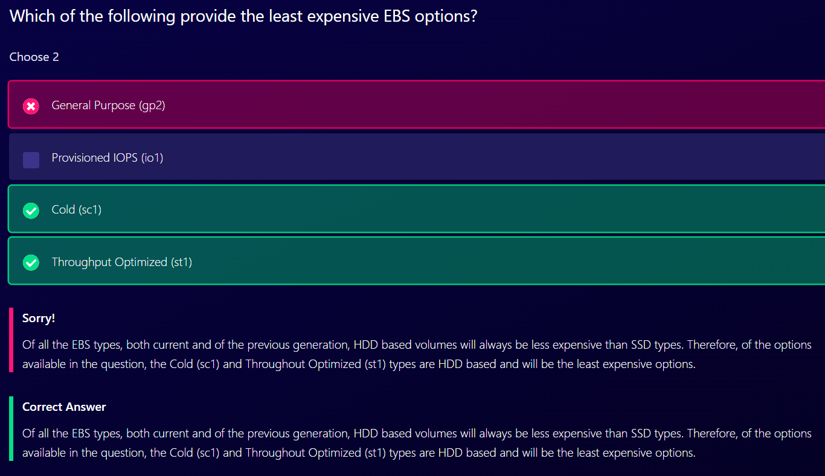

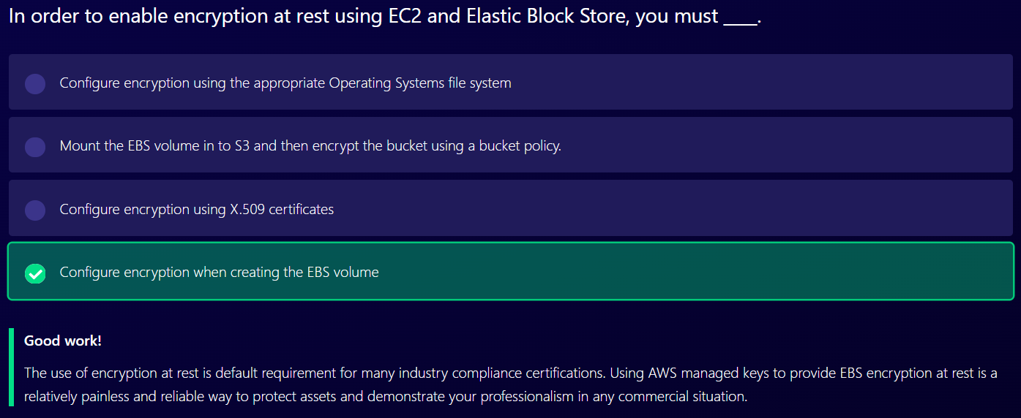

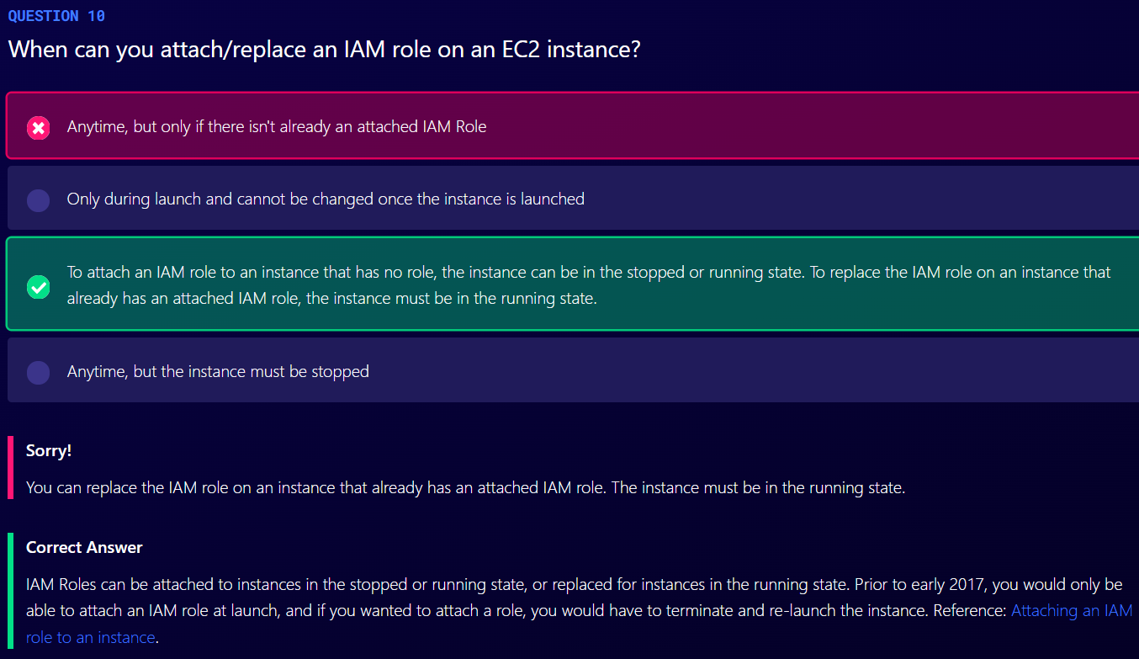

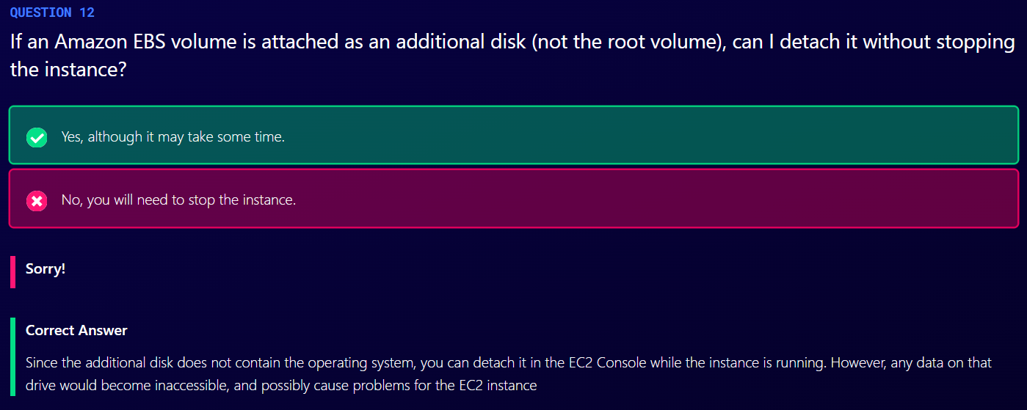

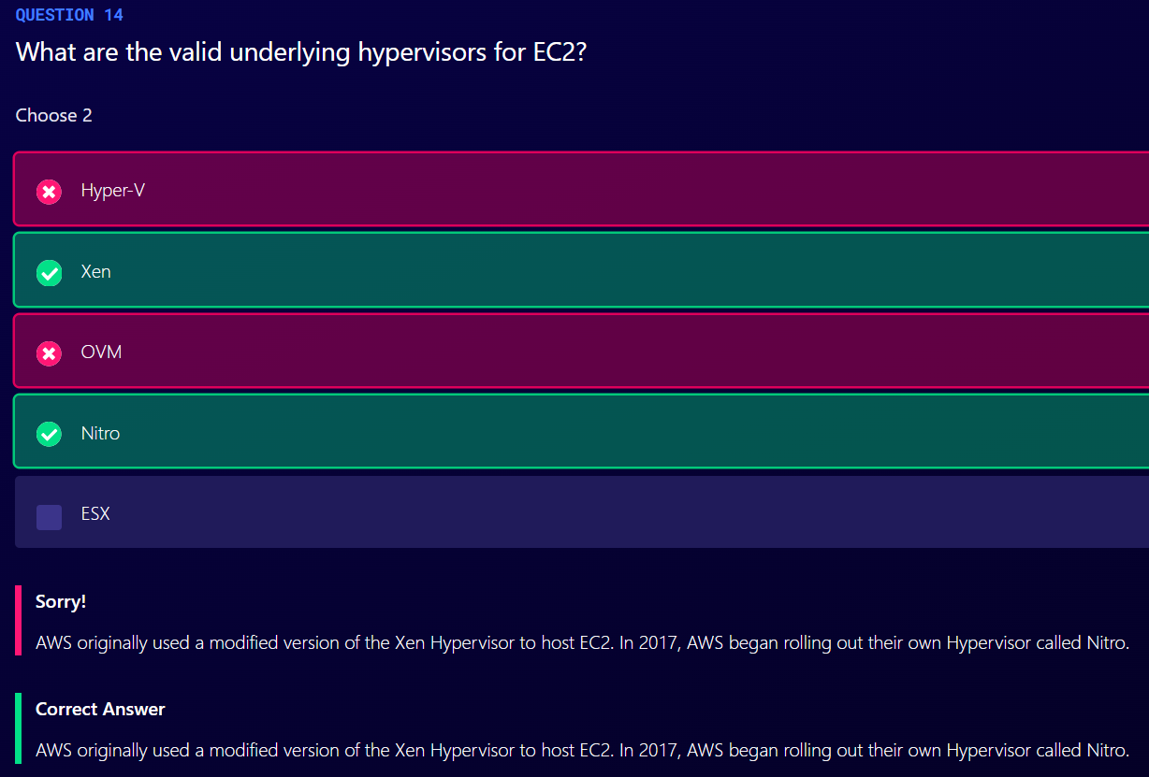

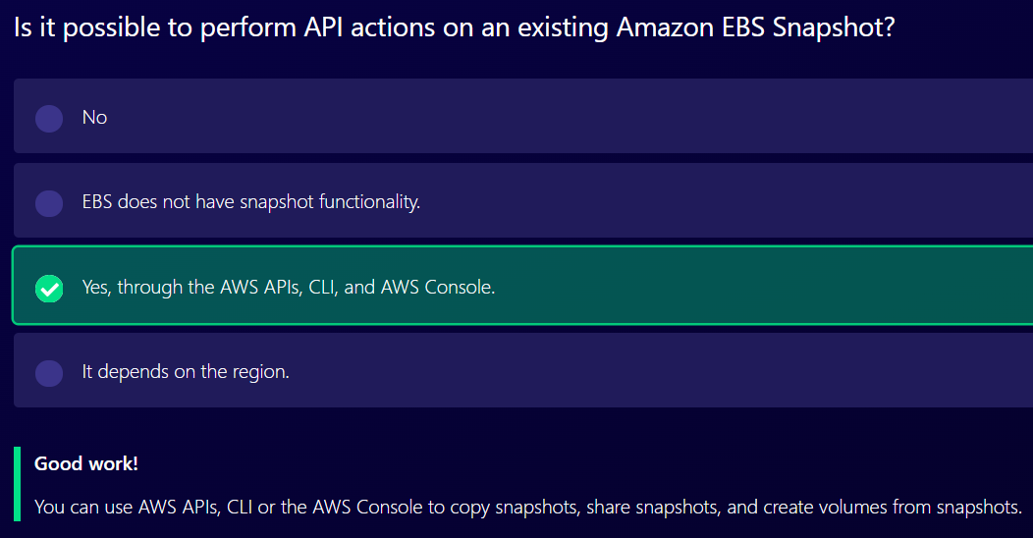

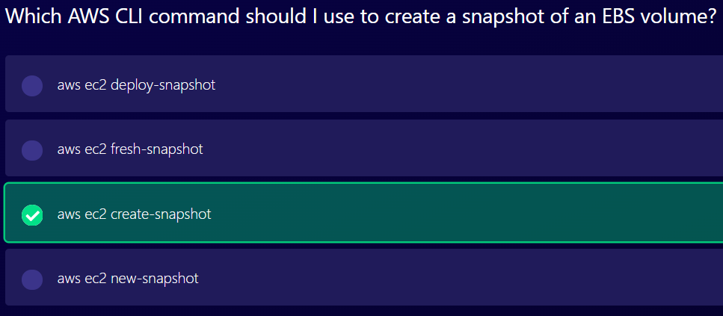

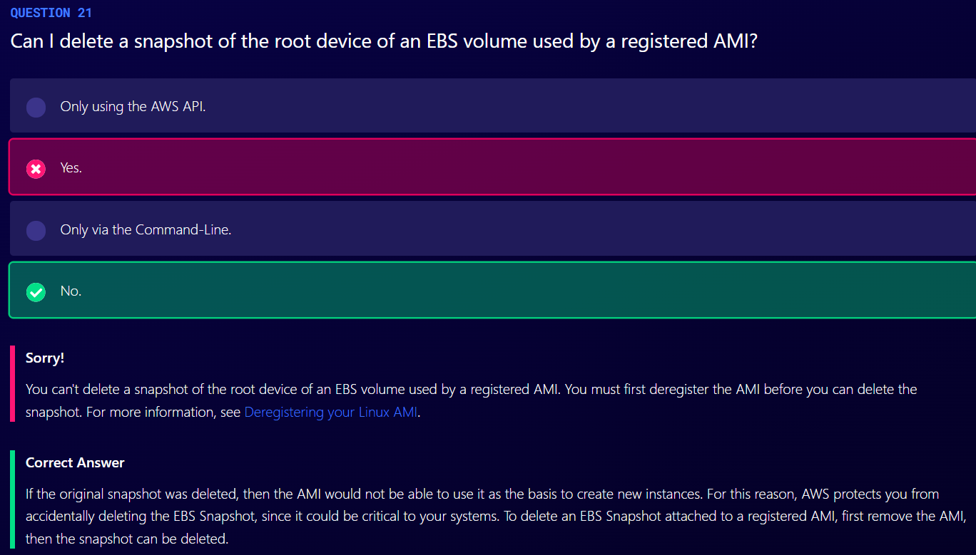

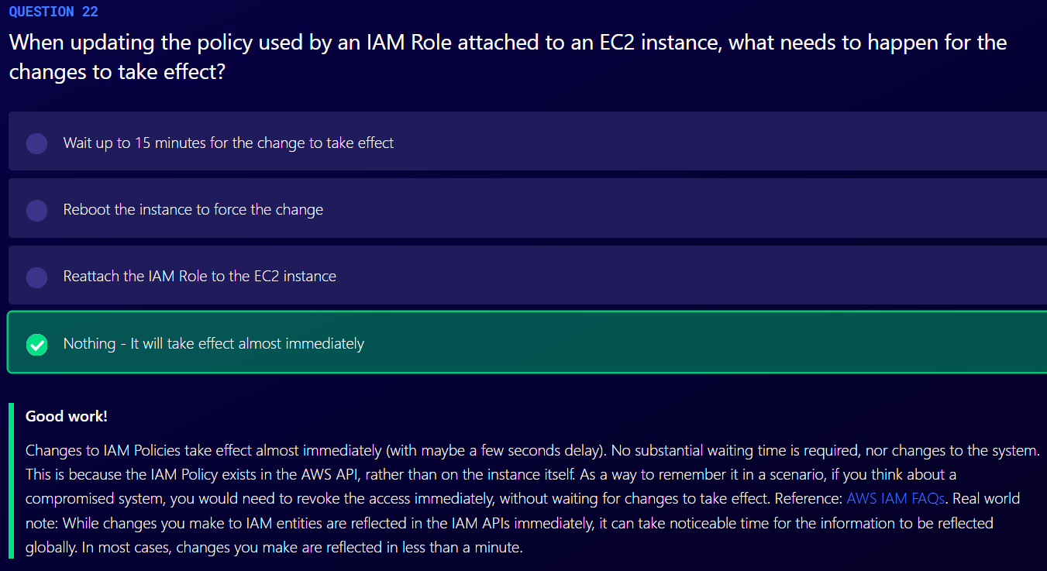

Databases

RDS

1. RDS is not serverless
2. RDS has two key features
   1. Multi-AZ – For Disaster Recovery
   2. Read Replicas – For Performance

Backups in RDS

1. There are two different types of backups for RDS
   1. Automated Backups
      1. Allows you to recover your database to any point in time within a retention period
      2. Retention period can be between one and 35 days
      3. It will take a full daily snapshot and we will also store transaction logs throughout the day and when we do a recovery, AWS will first choose the most recent daily backup and then apply the transaction logs relevant to that day and this allows you to do point in time recovery down to a second within the retention period.
      4. Automated backups are enabled by default and the backup data is stored in S3 and you get free storage space equal to the size of your database. So if you have an RDS instance of 10 Gb, you will get 10 Gb worth of storage
      5. Backups are taken within a defined window.
      6. During the backup window, storage I/O may be suspended while your data is being backed up and you may experience elevated latency.
   2. Database Snapshots
      1. They are done manually.
      2. They are stored even after you delete the original RDS instance, unlike automated backups
2. Whenever you restore either an Automated Backup or a manual Snapshot, the restored version of the database will be a new RDS instance with a new DNS endpoint.

Encryption at rest

1. Encryption is done using KMS service.
2. Once your RDS instance is encrypted, the data stored at rest in the underlying storage is encrypted, as are its automated backups, read replicas and snapshots.

Multi-AZ

It is available for following databases

1. SQL Server
2. Oracle
3. MySQL Server
4. PostgreSQL
5. MariaDB

Read Replicas

1. It used for performance improvement and scaling
2. It is not used for disaster recovery
3. It is available for following databases
   1. Oracle
   2. MySQL Server
   3. PostgreSQL
   4. MariaDB
   5. Aurora
4. Must have automatic backups turned on in order to deploy a read replica
5. You can have up to 5 read replica copies of any database
6. You can have read replicas of read replicas
7. Each read replicas will have its own DNS end point
8. You can have read replicas that have multi-AZ
9. You can create read replicas of multi-AZ source databases
10. You can have read replica in second region
11. Can be promoted to master, this will break the read replica

DynamoDB

1. Stored on SSD storage
2. Spread across 3 different AZ
3. Eventual Consistent Reads
   1. Default
   2. Consistency across all copies of data is usually reached within a second
   3. Repeating a read after a short time should return the updated data
   4. Best read performance
4. Strongly Consistent Reads
   1. Returns a result that reflects all writes that received a successful response prior to the read
   2. If you want to read data within one second of being written to table

DAX

1. Fully managed, highly available, in-memory cache
2. 10x performance improvement
3. Reduces request time from milliseconds to microseconds – even under load
4. No need for developers to manage caching logic
5. Compatible with DynamoDB API calls

Transactions

1. Multiple “all-or-nothing” operations
2. Financial transactions
3. Fulfilling orders
4. Two underlying reads or writes – prepare/commit
5. Up to 25 items or 4 MB of data

On-demand capacity

1. Pay per request pricing
2. Balance cost and performance
3. No minimum capacity
4. No charge for read/write – only storage and backups
5. Pay more per request than with provisioned capacity
6. Used for new product launches where you are not exactly sure what your consumption is going to look like

On-Demand Backup and Restore

1. Full backups at any time
2. Zero impact on table performance or availability
3. Consistent within seconds and retained until deleted
4. Operates within same region as the source table
5. Cannot do backup and restore across regions

Point-in-Time Recovery (PITR)

1. Helps you to protect against accidental writes and reads
2. Restore to any point in last 35 days
3. DynamoDB maintains incremental backups of your data
4. It is not enabled by default
5. You have to go in and turn this on manually and the latest restorable timestamp is typically 5 minutes in the past.

Streams

1. Time-ordered sequence of item-level changes in a table
2. Information is stored for 24 hours
3. Stream consists of stream records. Each stream record represents a single data modification in the DynamoDB table to which the stream belongs.
4. Each stream record is assigned a sequence number, reflecting the order in which the record was published to the stream and stream records are organized into groups or shards.
5. A shard acts as a container for multiple stream records and the shard contains information required for accessing and iterating through these records.
6. The stream records within a shard are removed automatically after 24 hours.
7. Use case
   1. Cross region replication
   2. Global tables
   3. You can establish relationships across tables, using streams
   4. It can be used for messaging or notification applications, any find of aggregation of filtering, analytical reporting, archiving, auditing, search
   5. Streams can be combined with lambda functions to get functionality that behaves a lot like stored procedures in traditional relational databases

Global Tables

1. Based on DynamoDB streams
2. Multi region redundancy for DR
3. No application rewrites
4. Replication latency under one second

Security in DynamoDB

1. Encryption at rest using KMS
2. Site-to-site VPN
3. Direct Connect (DX)
4. IAM Policies and Roles
5. Fine-grained access: allows users to access only certain attribute within DynamoDB table items
6. CloudWatch and CloudTrail: monitor tables using CloudWatch and CloudTrail
7. VPC endpoints for DynamoDB to enable EC2 instances in your VPC to use their private IP addresses, to access DynamoDB with no exposure to the public internet.

Redshift

1. Fast and powerful, fully managed, petabyte-scale data warehouse service in the cloud.
2. Customers can start small for just $0.25 per hour with no commitments or upfront costs and scale to a petabyte or more for $1,000 per terabyte per year, less than a tenth of most other data warehousing solutions.
3. Redshift can be configured as follows
   1. Single Node (160 Gb)
   2. Multi Node
      1. Leader Node: manages client connections and receive queries
      2. Compute Node: store data and perform queries and computations. Up to 128 compute nodes
4. Advanced compression
   1. Columnar data stores can be compressed much more than row based data stores
   2. Redshift does not require indexes or materialized views, and so uses less space than traditional relational database systems
   3. When loading data into an empty table, Redshift automatically samples your data and selects the most appropriate compression scheme
5. Massive Parallel Processing (MPP)
   1. Redshift automatically distributes data and query load across all nodes.
6. Backups
   1. Enabled by default with a 1 day retention period
   2. Maximum retention period is 35 days
   3. Redshift always attempts to maintain at least three copies of your data (the original and replica on the compute nodes and a backup in Amazon S3)
   4. Redshift can also asynchronously replicate your snapshots to S3 in another region for disaster recovery
7. Redshift is priced as follows:
   1. Compute Node Hours
      1. Total number of hours you run across all your compute nodes for the billing period
      2. You are billed for 1 unit per node per hour, so a 3-node data warehouse cluster running persistently for an entire month would incur 2,160 instance hours
      3. You will not be charged for leader node hours. Only compute nodes will incur charge.
   2. Backup
   3. Data transfer (only within a VPC, not outside it)
8. Redshift Security
   1. Encrypted in transit using SSL
   2. Encrypted at rest using AES-256 encryption
9. Redshift Availability
   1. Currently only available in 1 AZ
   2. Can restore snapshots to new AZs in the event of an outage
10. Redshift is used for business intelligence

Aurora

1. Starts with 10GB, scales in 10GB increments to 64TB
2. Compute resources can scale up to 32vCPUs and 244GB of memory
3. 2 copies of your data is contained in each availability zone, with minimum of 3 AZ, 6 copies of data
4. Aurora is designed to transparently handle the loss of up to 2 copies of data without affecting write availability and up to 3 copies without affecting read availability
5. Aurora storage is also self-healing. Data blocks and disks are continuously scanned for errors and repaired automatically
6. Three types of Aurora Replicas are available
   1. Aurora Replicas (currently 15)- automated failover is only available with Aurora Replicas
   2. MySQL Read Replicas (currently 5)
   3. PostgreSQL (currently 1)
7. Backups
   1. Automated backups are always enabled on Amazon Aurora DB instances. Backups do not impact database performance.
   2. You can also take snapshots with Aurora. This also does not impact on performance.
   3. You can share Aurora Snapshots with other AWS accounts.

Amazon Aurora Serverless

1. On-demand, autoscaling configuration for the MySQL compatible and PostgreSQL compatible editions of Amazon Aurora.
2. An Aurora Serverless DB cluster automatically starts up, shuts down, and scales capacity up or down based on your application’s needs.
3. It provides a relatively simple, cost-effective option for infrequent, intermittent or unpredictable workloads

ElastiCache

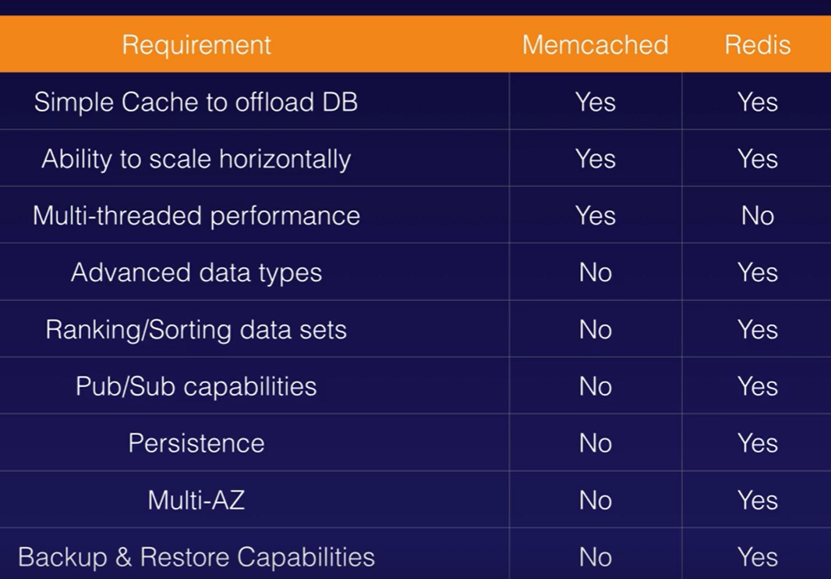

Redis is multi-AZ. You can do backups and restores of Redis.

Database Migration Service (DMS)

1. AWS DMS creates the tables and associated primary keys if they don’t exist on the target. You can pre-create the target tables manually, or you can use AWS Schema Conversion Tool (SCT) to create some or all of the target tables, indexes, views, triggers, etc.
2. SCT is required for heterogenous migration.
3. Sources and Targets
   1. Sources
      1. On-premises and EC2 instances databases: Oracle, Microsoft SQL Server, MySQL, MariaDB, PostgreSQL, SQP, MongoDB, DB2
      2. Azure SQL Database
      3. Amazon RDS (including Aurora)
      4. Amazon S3
   2. Targets
      1. On-premises and EC2 instances database: Oracle, Microsoft SQL Server, MySQL, MariaDB, PostgreSQL, SAP
      2. RDS
      3. Redshift
      4. DynamoDB
      5. S3
      6. Elasticsearch
      7. Kinesis Data Streams
      8. DocumentDB

Caching Strategies in AWS

1. Caching is a balancing act between up-to-date, accurate information and latency.
2. The following service have caching capabilities
   1. CloudFront
   2. API Gateway
   3. ElastiCache – Memcached and Redis
   4. DynamoDB Accelerator (DAX)

EMR (Elastic Map Reduce)

1. The node types in Amazon EMR are as follows:
   1. Master Node
      1. A node that manages the cluster
      2. The master node tracks the status of tasks and monitors the health of the cluster
      3. Every cluster has a master node
   2. Core node
      1. A node with software component that runs tasks and stores data in the Hadoop Distributed File System (HDFS) on your cluster.
      2. Multi-node clusters have at least one core mode.
   3. Task mode
      1. A node with software components that only runs tasks and does not store data in HDFS.
      2. Task nodes are optional.
2. By default, log data is stored on the master node. You can configure a cluster to periodically archive the log files stored on the master node to Amazon S3. This ensures the log files are available after the cluster terminates, whether this is through normal shutdown or due to an error. Amazon EMR archives the log files to Amazon S3 at five-minute intervals. (used in case master node fails)

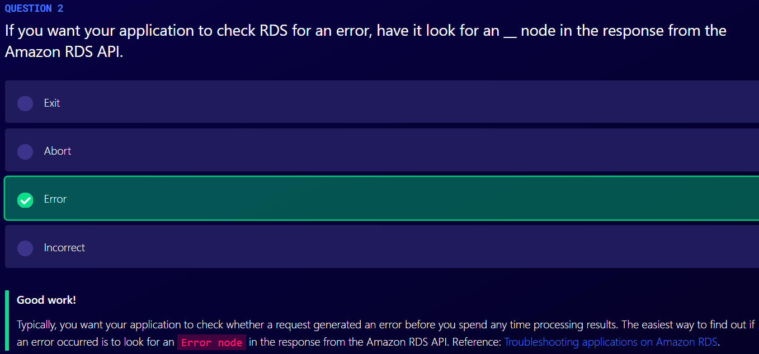

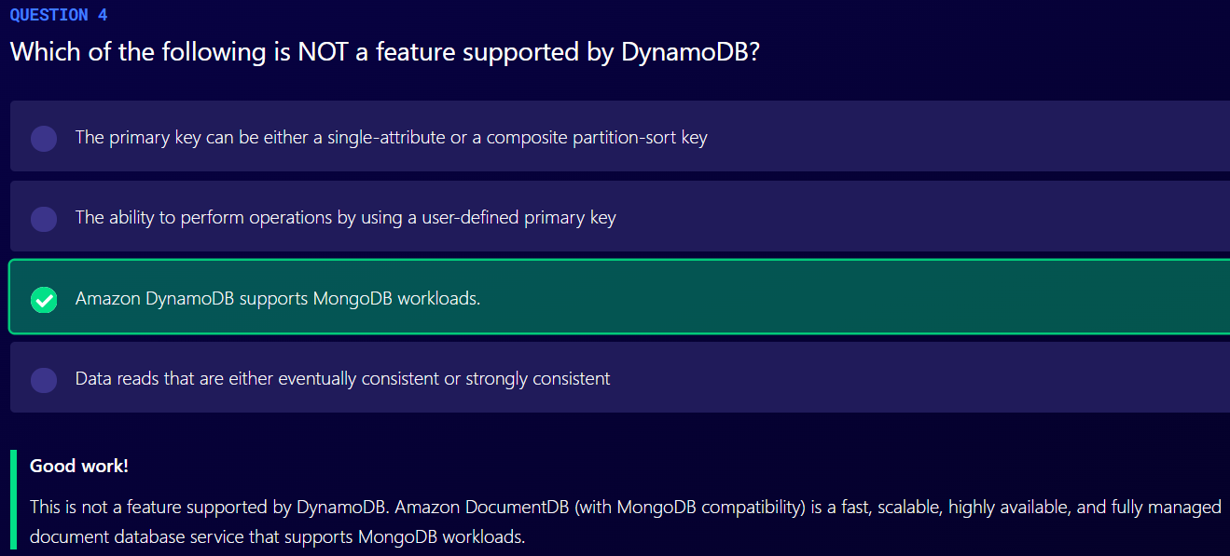

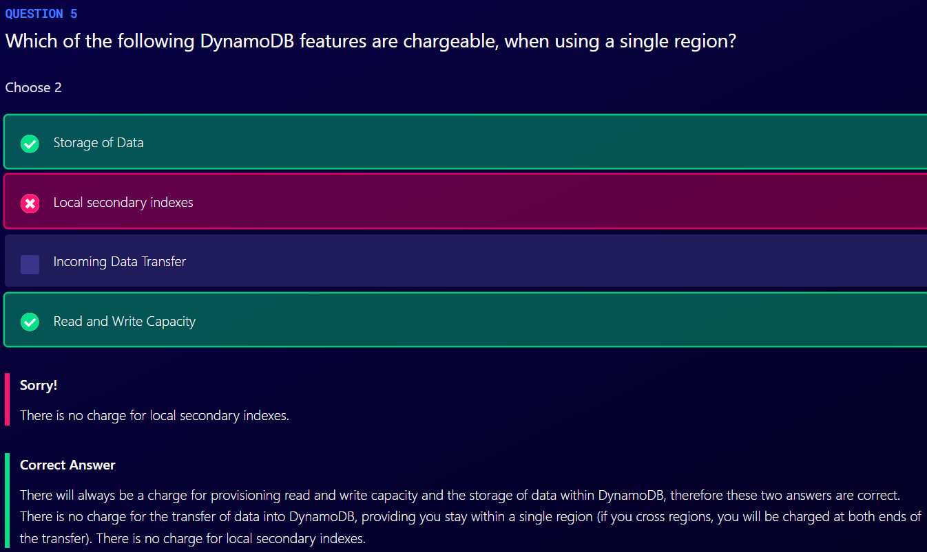

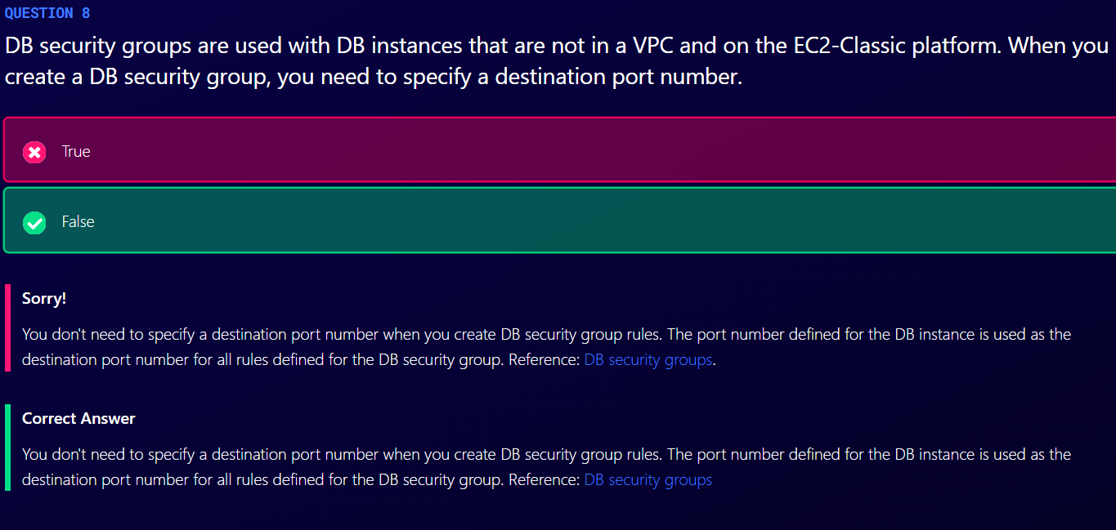

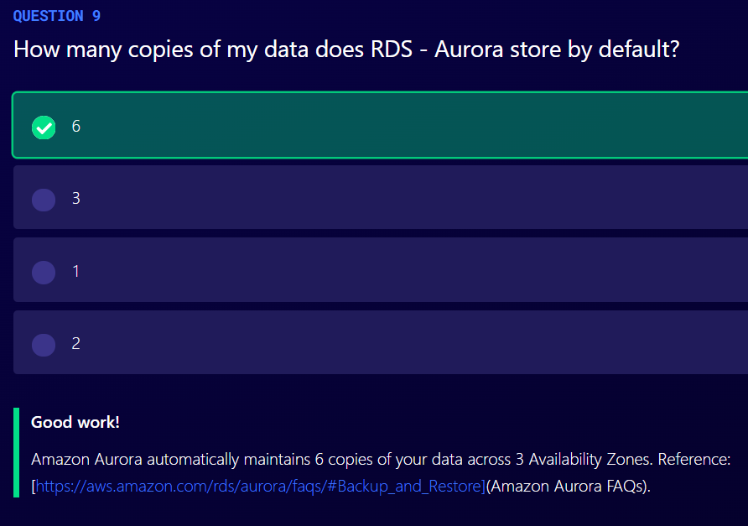

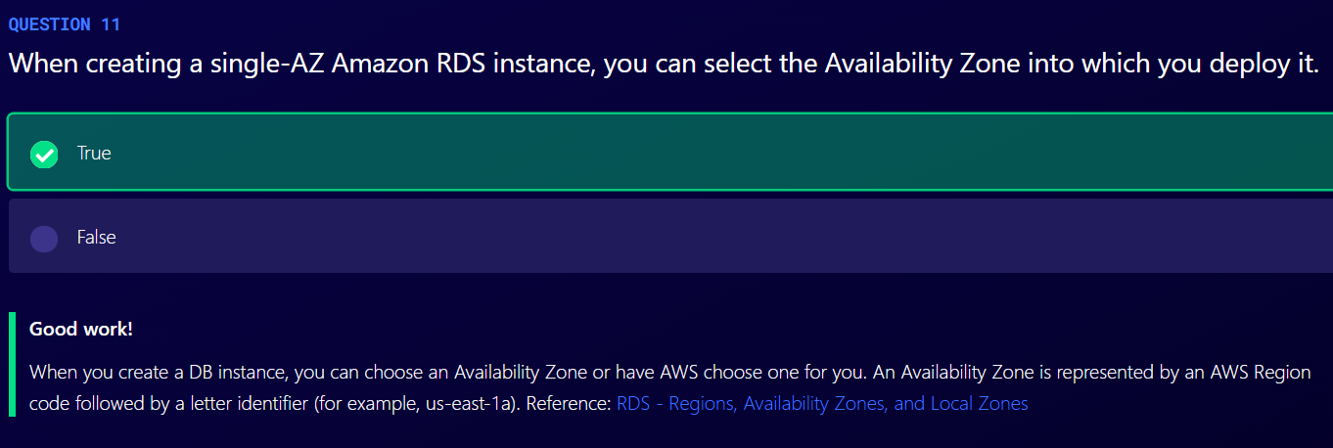

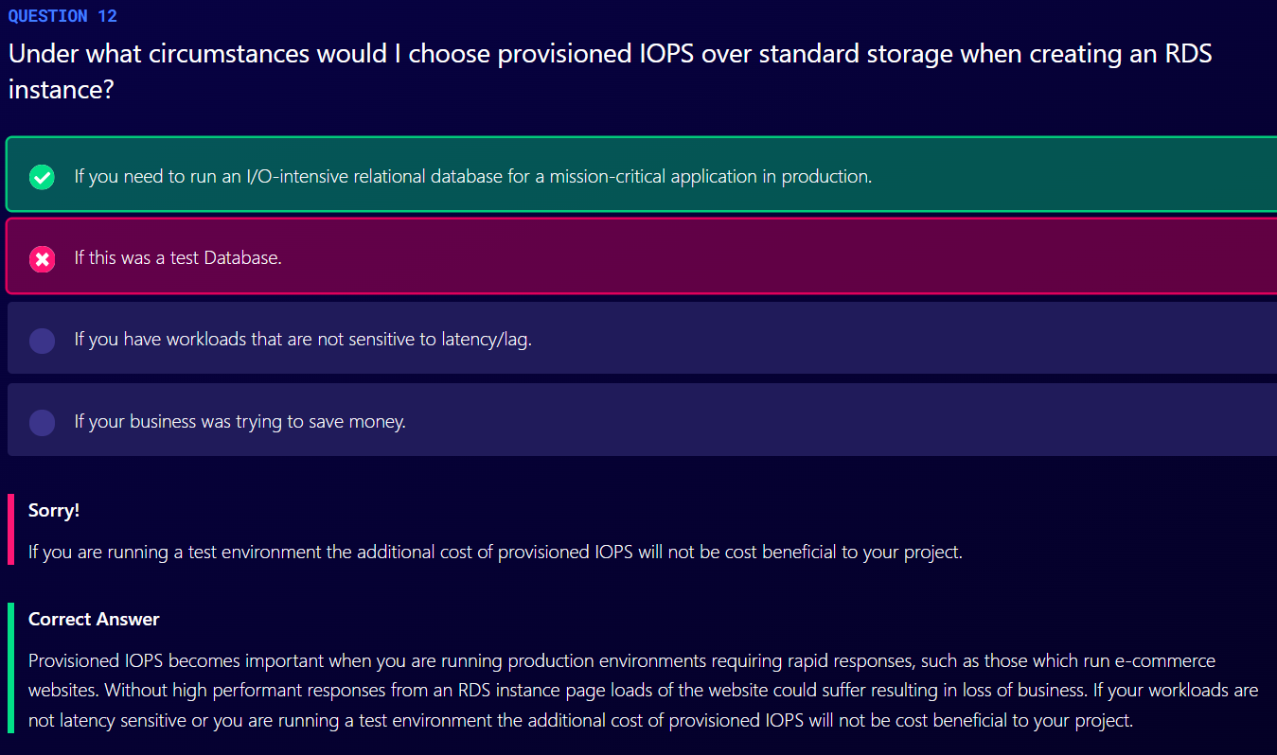

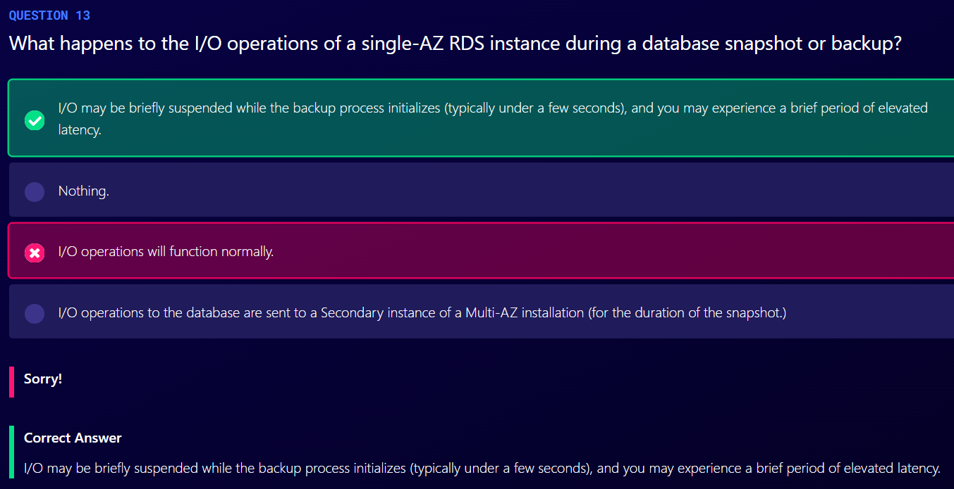

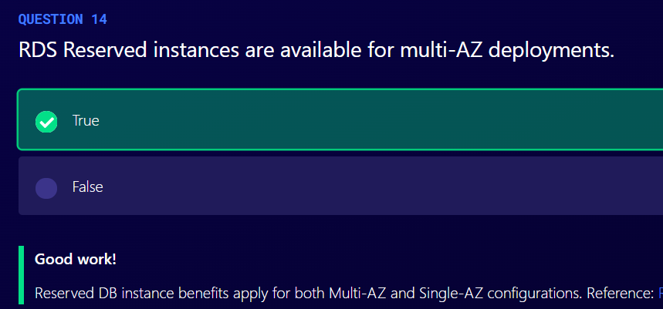

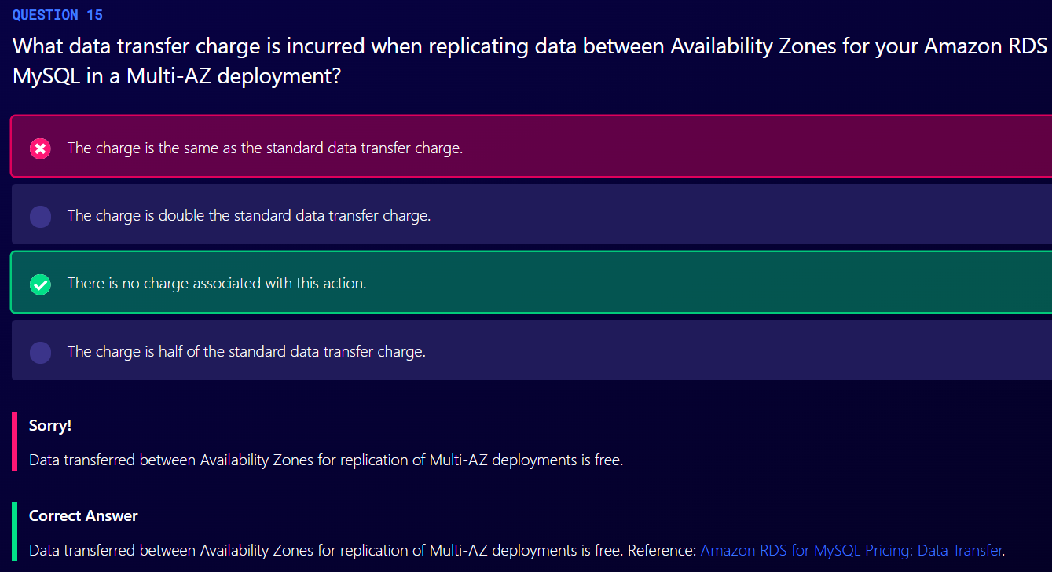

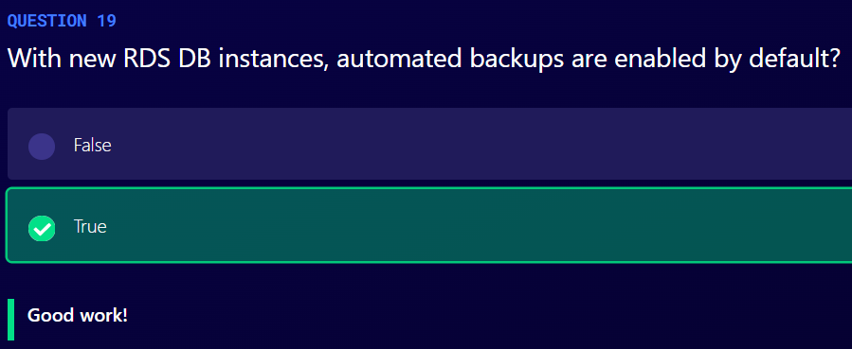

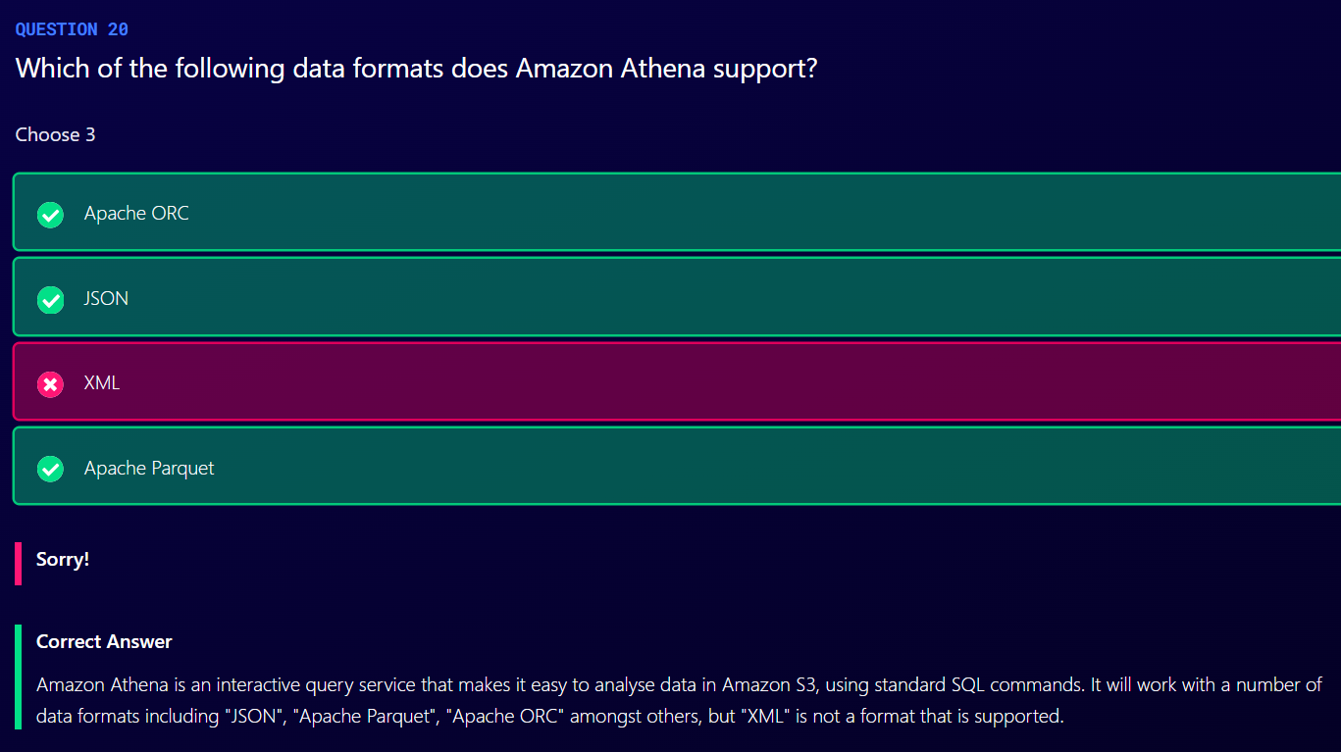

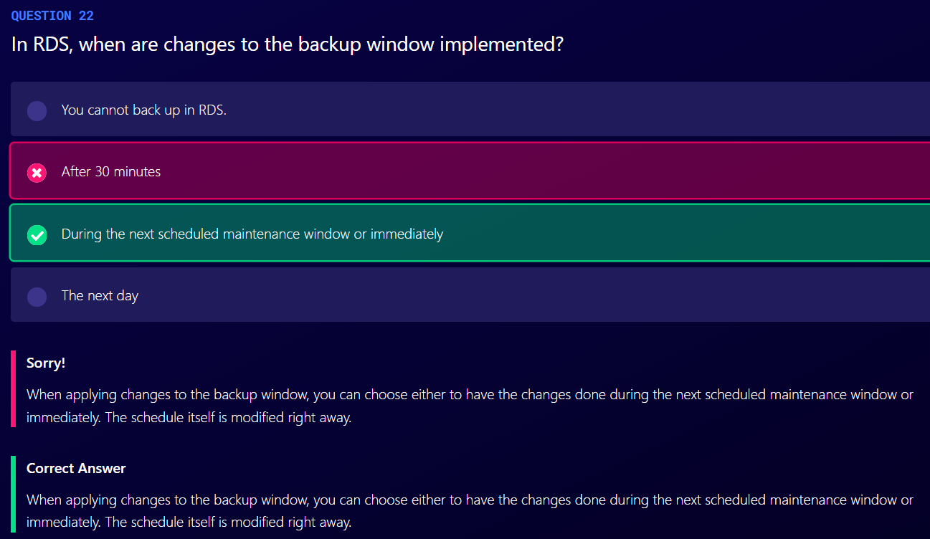

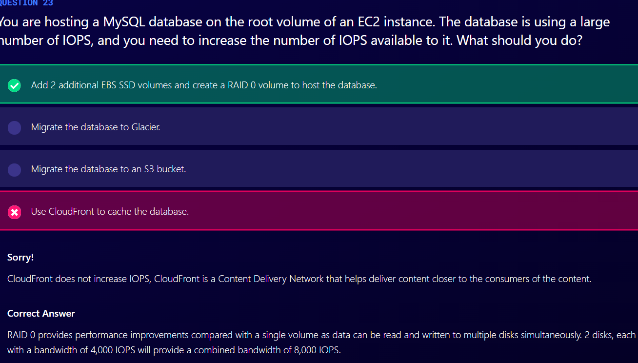

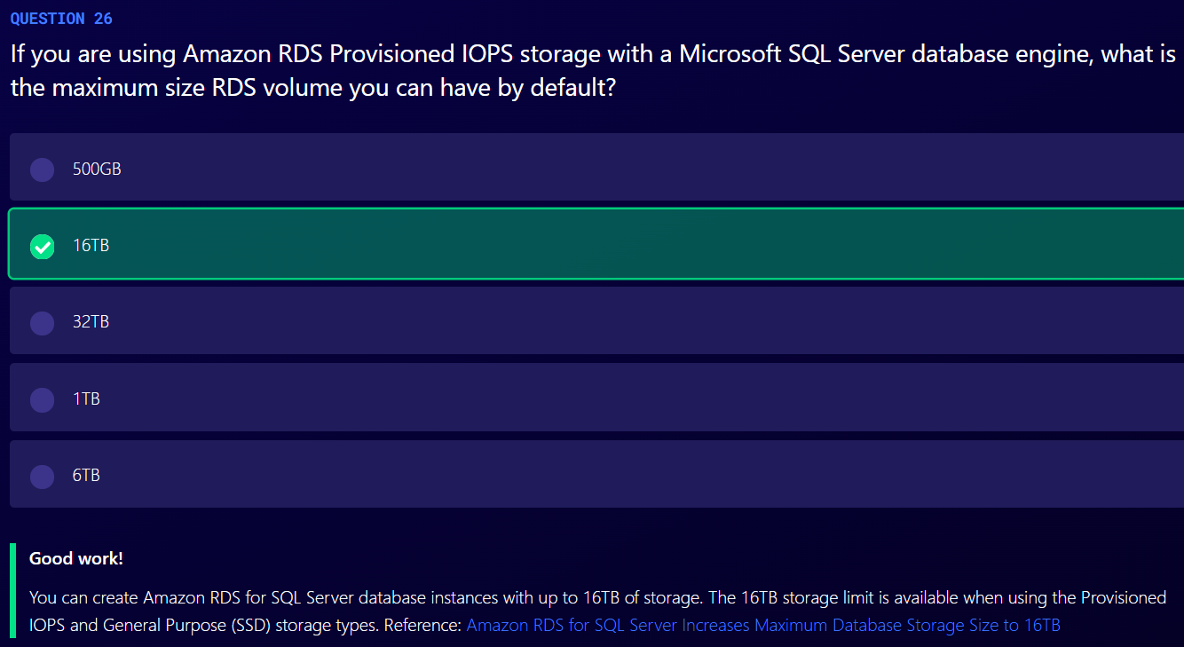

AWS Directory Service

1. Family of managed services
2. Connect AWS resources with on-premises AD
3. This is standalone directory in the cloud
4. It allows users to access AWS resources and applications with your existing corporate credentials. You can also log into the AWS management console using those same existing corporate credentials
5. Directory service also enables single sign on across any domain joined EC2 instnace. So, if you have your fleet of EC2 instances, all joined to an Active Directory domain, you don’t need to manage credentials on any individual EC2 instances

AWS Managed Microsoft AD

Responsibility of AWS and Customer

AWS

1. Multi-AZ deployment
2. Patch, monitor, recover
3. Instance rotation
4. Snapshot and restore

Customer

1. Users, groups, GPO(Group Control Policies)
2. Standard AD tools
3. Scale out DCs
4. Trusts (resource forest)
5. Certificate authorities (LDAPS)
6. Federation

Simple AD

1. Small <=500 users, large<=5000 users
2. Does not support trusts (cannot join simple AD to on-premises AD)

Cloud Directory

1. Directory based store for developers
2. Multiple hierarchies with hundreds of millions of objects
3. Use case: Application that implement org charts, course catalogs, device registries
4. Fully managed service

AD Trust

1. We use AD Trust to extend existing Active Directory inside AWS to your on premises environment.

Amazon Cognito User Pools

1. Managed user directory for SaaS applications
2. Allows Sign-up and sign-in for web and mobile applications
3. Works with social media identities
4. Example: you can log into a SaaS application using your Facebook, Google of Amazon credentials.

AD vs Non-AD Compatible Services

1. AD Compatible
   1. Managed Microsoft AD
   2. AD Connector
   3. Simple AD
2. Not AD Compatible
   1. Cloud Directory
   2. Cognito user pools

Amazon Resource Name (ARN)

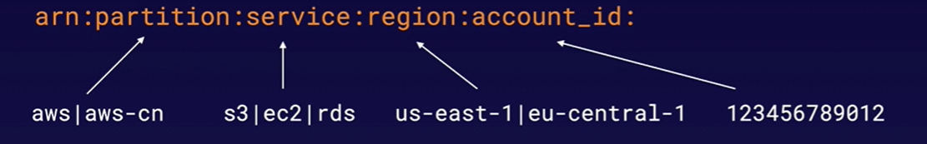

1. Helps you to uniquely identify each resources in AWS
2. All ARNs begin with
   1. Arn:partition:service:region:account_id:
3. And end with
   1. Resource
   2. Resource_type/resource
   3. Resource_type/resource/qualifier
   4. Resource_type/resource:qualifier
   5. Resource_type:resource
   6. Resource_type:resource:qualifier
4. Example
   1. Arn:aws:iam::123456789012:user/mark
   2. Arn:aws:s3::my_awesome_bucket/image.png
   3. Arn:aws::dynamodb:us-east-1:123456789012:table/orders
   4. Arn:aws:ec2:us-east-1:123456789012:instance/*

IAM Policies

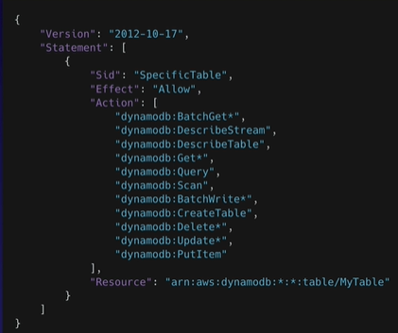

1. Any policies that are not explicitly allowed are implicitly denied
2. Each statement in IAM Policy matches an AWS API request.
3. Action in policy contains service_name:action_name
4. Some action might contain * which means all API request that starts with. Ex: dynamodb:Get* implies all API requests that start with Get
5. There are two types of policies: AWS Managed policies and Customer Managed Policies
6. AWS Managed Policies cannot be edited
7. Policies should be attached for it to become effective. Only attached policies have effect
8. If you have a policy that is an explicit deny that overrides anything else in any other policies.
9. When you have multiple policies attached to either an identity or resource AWS will join or union, all of those policies together when it performs its evaluation.

Permission boundaries

1. Used to delegate administration to other users
2. Prevent privilege escalation or unnecessarily broad permissions
3. Control maximum permissions an IAM policy can grant
4. Use cases
   1. Developers creating roles for lambda functions
   2. Application owners creating roles for EC2 instances
   3. Admins creating ad hoc users

AWS RAM (Resource Access Manager)

1. Allows resource sharing between accounts
2. Following resources can be shared using RAM
   1. App Mesh
   2. Aurora
   3. CodeBuild
   4. EC2
   5. EC2 Image Builder
   6. License Manager
   7. Resource Groups
   8. Route 53
3. Second account should accept request from first account.

AWS Single Sign-On

1. Helps centrally manage access to AWS accounts and business applications
2. You can sign in to AWS accounts and third party accounts in one place with AWS SSO portal
3. You can manage user permissions for all your AWS resources across all your accounts using AWS Organizations
4. SSO also integrates with active directory or any SAML 2.0 identity provider, for example, Azure AD

Route 53

.com.au

.au – top level domain

.com – second level domain name

Domain Registrars

1. To ensure uniqueness of domain names across the Internet
2. Each domain name becomes registered in a central database known as WhoIS database
3. Popular domain registrars include:
   1. Amazon
   2. GoDaddy.com
   3. 123-reg.co.uk

Common DNS types are:

1. SOA Records
2. NS Records
3. A Records
4. CNAMES
5. MX Records
6. PTR Records: used to convert IP address to domain name, opposite of A record

Record

1. A – translate domain to an IP address
2. CName – resolve one domain name to another
3. Alias Records- used to map resource record sets in your hosted zone to Elastic Load Balancers, CloudFront distributions or S3 buckets that are configures as websites.
4. CName and Alias Records are similar to one another but CNAME cannot be used for naked domain name (zone apex record). You cannot have a CNAME for http://acloud.guru , it must be either an A record or an alias.

Note

1. ELBs do not have pre-defined IPv4 addresses; you resolve to them using a DSN name.
2. You can buy domain names directly with AWS
3. It can take up to 3 days to register depending on the circumstances

Routing Policies

1. Simple Routing
   1. If you choose the simple routing policy you can only have one record with multiple IP addresses
   2. If you specify multiple values in a record, Route 53 returns all values to the user in a random order
2. Weighted Routing
   1. Allows you to split your traffic based on different weights assigned.
   2. For example, you can set 10% of your traffic to go to US-EAST-1 and 90% to go to US-WEST-1.
   3. You can set health checks on individual record sets.
3. Latency-based Routing
   1. Allows you to route your traffic based on lowest network latency for your end user (i.e. which region will give them the fastest response time)
   2. You can set health checks on individual record sets
4. Failover Routing
   1. Used when you want to create an active/passive set up
   2. Route53 will monitor the health of your primary site using a health check.
   3. A health check monitors the health of your end points.
   4. You can set health checks on individual record sets.
5. Geolocation Routing
   1. Lets you choose where your traffic will be sent based on the geographic location of your users (is the location from which DNS queries originate)
   2. Location can be set based on countries and continents
   3. You can set health checks on individual record sets
6. Geoproximity Routing (traffic flow only)
   1. Lets traffic to your resources based on geographical location of your users and your resources.
   2. You can also optionally choose to route more traffic or less to a give resource by specifying a value, known as bias.
   3. To use Geoproximity routing, you must use Route 53 traffic flow.
7. Multivalue Answer Routing
   1. Lets you configure Amazon Route 53 to return multiple values, such as IP addresses for your web servers, in response to DNS queries
   2. You can specify multiple values for almost any record, but multi-value answer routing also lets you check the health of each resource, so Route 53 returns only values for healthy resources.
   3. This is similar to simple routing however it allows you to put health checks in each record set.

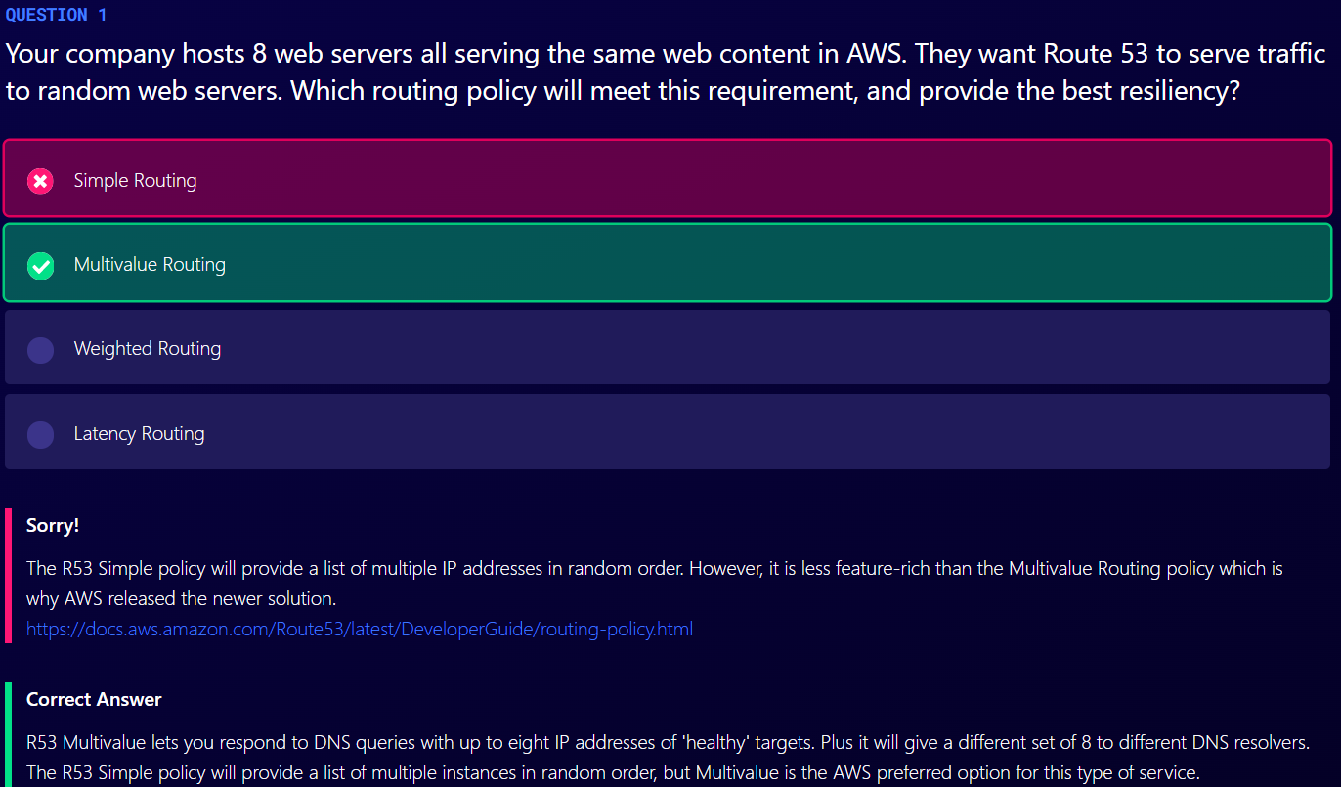

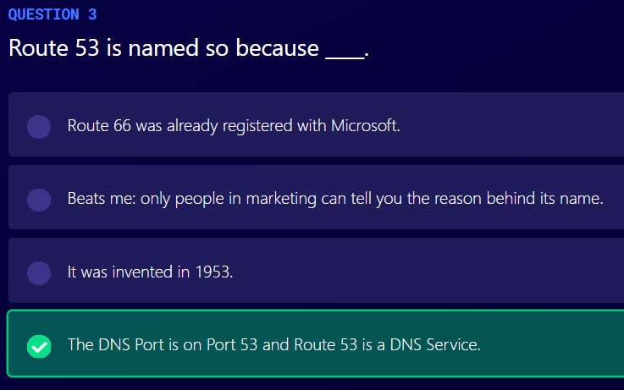

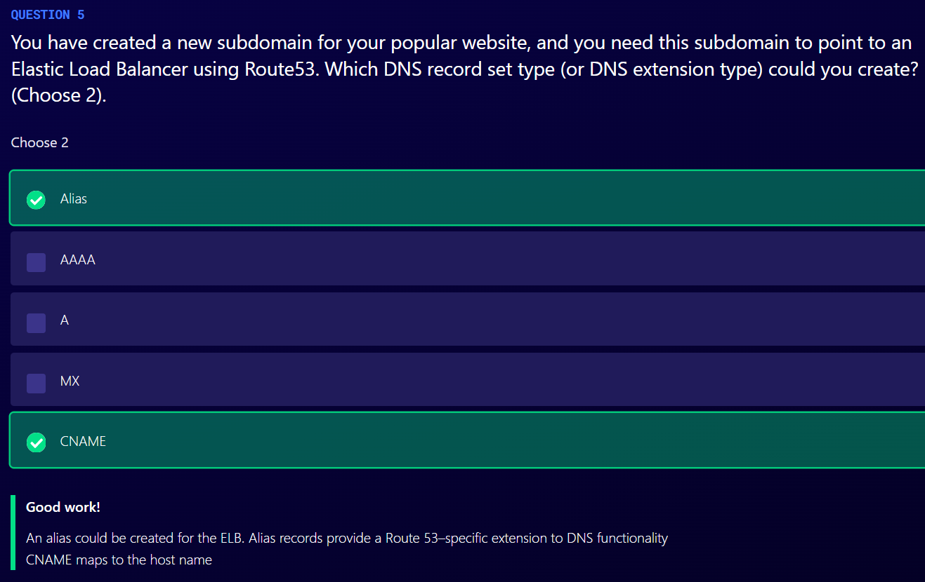

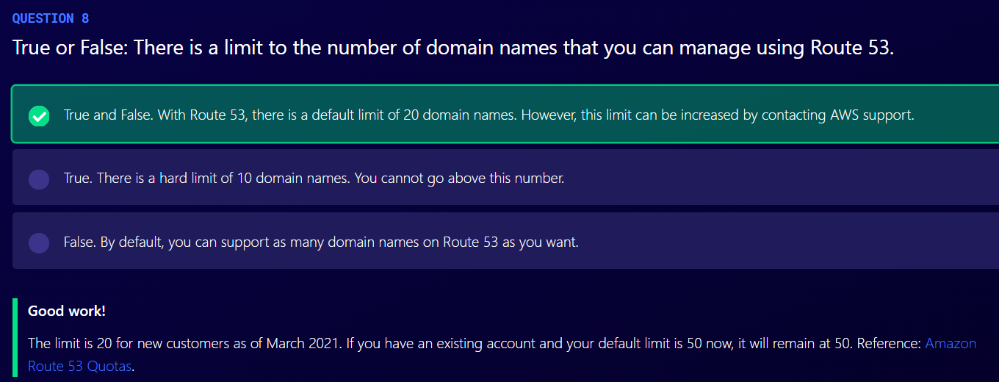

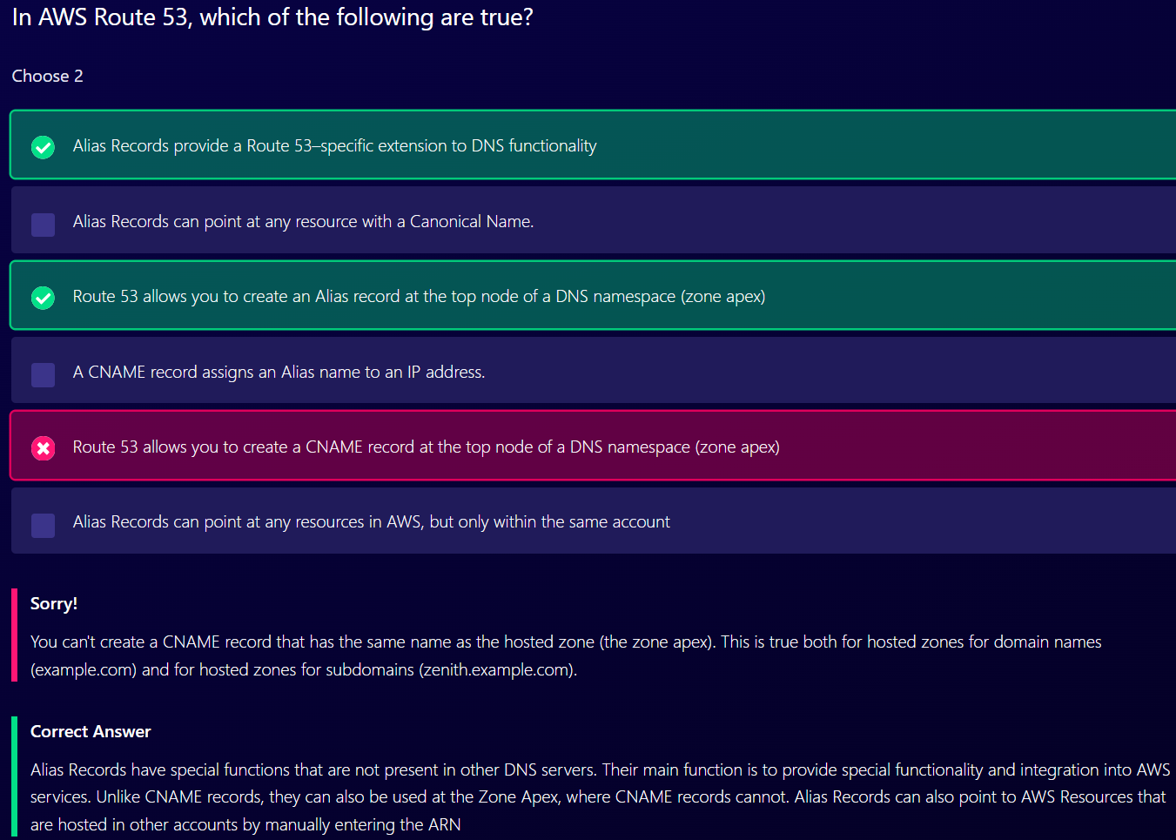

VPC

1. Largest subnet in VPC is 10.0.0.0/16

Default VPC

1. All subnets in default VPC are internet accessible

Each EC2 instance has both a public and private IP address.

VPC Peering

1. Allows you to connect one VPC with another via direct network route using private IP addresses
2. Instances behave as if they were on the same private network
3. You can peer VPC’s with other AWS accounts as well as with other VPCs in the same account
4. No transitive peering
5. You can peer between regions

NAT Instances

1. When creating a NAT instance, disable Source/Destination check on the instance
2. NAT instances must be in a public subnet
3. There must be a route out of private subnet to the NAT instance, in order for this to work
4. The amount of traffic that NAT instances support depends on the instance size. If you are bottlenecking, increase the instance size.
5. Associated with security groups

NAT Gateway

1. There can only be one NAT gateway inside one AZ. NAT Gateways cannot span AZs
2. Preferred by enterprise
3. Starts at 5Gbps and scales currently to 45 Gbps
4. No need to patch
5. Not associated with security groups
6. Automatically assigned a public IP address
7. Remember to update your route tables
8. No need to disable Source/Destination checks
9. If you have resources in multiple AZ and they share one NAT Gateway, in the event that the NAT gateway’s AZ is down, resources in the other AZ lose internet access. To create an AZ-independent architecture, create a NAT gateway in each AZ and configure your routing to ensure that resources use the NAT gateway in the same AZ.

Network Access Control list

1. Your VPC automatically comes with a default NACL and by default it allows all outbound and inbound traffic.
2. You can create custom network ACLs. By default, each custom network ACL denies all inbound and outbound traffic until you add rules.
3. Each subnet in your VPC must be associated with a NACL. If you don’t explicitly associate a subnet with a NACL, the subnet is automatically associated with the default NACL.
4. Block IP addresses using NACL not Security Groups.
5. You can associate a NACL with multiple subnets. However, a subnet can be associated with only one NACL at a time. When you associate a NACL with a subnet, the previous association is removed.
6. NACLs contain a numbered list of rules that is evaluated in order, starting with the lowest numbered rule.
7. NACL have separate inbound and outbound rules and each rule can either allow or deny traffic.
8. NACLs are stateless; responses to allowed inbound traffic are subject to the rules for outbound traffic (and vice versa).

Note:

You need a minimum of two public subnets to deploy an internet facing load balancer.

VPC Flow Logs

1. Feature that enables you to capture information about the IP traffic going to and from network interfaces in your VPC
2. Flow log data is stored using Amazon CloudWatch Logs
3. After you have created a flow log, you can view and retrieve its data in Amazon CloudWatch logs
4. Flow logs can be created at 3 levels
   1. VPC
   2. Subnet
   3. Network Interface Level
5. You cannot enable flow logs for VPCs that are peered with your VPC unless the peer VPC is in your account. That means both VPCs should be in same account.
6. You can tag flow logs
7. After you have created a flow log, you cannot change its configuration; for example, you cannot associate a different IAM role with the flow log.
8. Not all IP traffic is monitored
   1. Traffic generated by instances when they contact the Amazon DNA server is not monitored. If you use your own DNS server, then all traffic to that DNS server is logged.
   2. Traffic generated by a Windows instance for Amazon Windows license activation is not monitored
   3. Traffic to and from 169.254.169.254 for instance metadata is not monitored
   4. DHCP traffic is not monitored.
   5. Traffic to the reserved IP address for the default VPC router is not monitored

Bastion Hosts

1. A bastion is used to securely administer EC2 instances (using SSH or RDP). Bastions are called Jump Boxes in Australia.
2. You cannot use a NAT Gateway as a Bastion host.

Steps to creating a Direct Connect Connection

1. Create a virtual interface in the Direct Connect console. This is public virtual interface
2. Go to VPC console and then to VON connections. Create a customer gateway
3. Create a virtual private gateway
4. Attach the virtual private gateway to the desired VPC
5. Select VON connections and create new VPN connection
6. Select the virtual private Gateway and the Customer Gateway
7. Once the VPN is available, setup the VON on the customer gateway or firewall

AWS Global Accelerator

1. Service in which you create accelerators to improve availability and performance of your applications for local and global users
2. Directs traffic to optimal endpoints over the AWS global network.
3. This improves the availability and performance of your Internet applications.
4. By default, Global Accelerator provides you with two static IP addresses that you associate with your accelerator
5. Alternatively, you can bring your own.
6. You can control traffic using traffic dials. This is done within the endpoint group.
7. You can control weighting to individual end points using weights.
8. AWS Global Accelerator includes the following components
   1. Static IP addresses
      1. By default, Global Accelerator provides you with two static IP addresses that you associate with your accelerator.
   2. Accelerator
      1. Accelerator directs traffic to optimal endpoints over the AWS global network to improve the availability and performance of your internet applications.
      2. Each accelerator includes one or more listeners.
   3. DNS name
      1. Global Accelerator assigns each accelerator a default DNS name similar to a1234567890abcdef.awsglobalaccelerator.com- that points to the static IP addresses that Global Accelerator assigns to you.
   4. Network Zone
      1. A network zone services the static IP addresses for your accelerator from a unique IP subnet.
      2. Similar to AZ, a network zone is a isolated unit with its own set of physical infrastructure.
   5. Listener
      1. A listener processes inbound connections from clients to Global Accelerator, based on the port and protocol that you configure.
      2. Global Accelerator supports both TCP and UDP protocols.
      3. Each listener has one or more endpoint groups associated with it, and traffic is forwarded to endpoints in one of the groups
   6. Endpoint Group
      1. Each endpoint group is associated with a specific AWS Region.
      2. It includes one or more endpoints in the Region.
      3. You can increase or reduce the percentage of traffic that would be otherwise directed to an endpoint group by adjusting a setting called a traffic trail.
      4. The traffic dial lets you easily do performance testing or blue/green deployment testing for new releases across different AWS Regions
   7. Endpoint
      1. Endpoints can be Network Load Balancers, Application Load Balancers, EC2 instances or Elastic IP addresses.
      2. ALB endpoint can be an internet-facing or internal

AWS PrivateLink

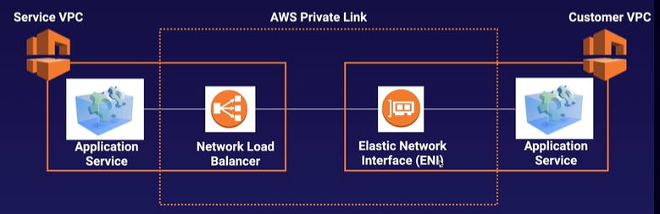

1. Way of peering VPCs to tens, hundreds, or thousands of customer VPCs
2. Way of sharing your applications within your own VPC to multiple VPCs
3. Best way to expose a service VPC to tens, hundreds, or thousands of customer VPCs
4. Does not requires VPC peering; no route tables, NAT, IGWs, etc.
5. Requires a Network Load Balancer on the service VPC and an ENI on the customer VPC

Transit Gateway

1. Allows you to have transitive peering between thousands of VPCs and on-premises data centers
2. Works on a hub-and-spoke model
3. Works on a regional basis, but you can have it across multiple regions
4. You can use it across multiple AWS accounts using RAM (Resource Access Manager)
5. You can use route tables to limit how VPCs talk to one another
6. Works with Direct Connect as well as VPN connections
7. Supports IP multicast (not supported by any other AWS services)

AWS VPN CloudHub

1. If you have multiple sites, each with its own VPN connection, you can use AWS VPN CloudHub to connect those sites together
2. Hub-and-spoke model
3. Low cost, easy to manage
4. It operates over the public internet, but all traffic between the customer gateway and the AWS VPN CloudHub is encrypted

AWS Network Costs

1. Use private IP addresses over public IP addresses to save on costs.
2. If you want to cut all network costs, group your EC2 instances in the same AZ and use private IP addresses. This will be cost-free, but make sure to keep in mind single point of failure issues.

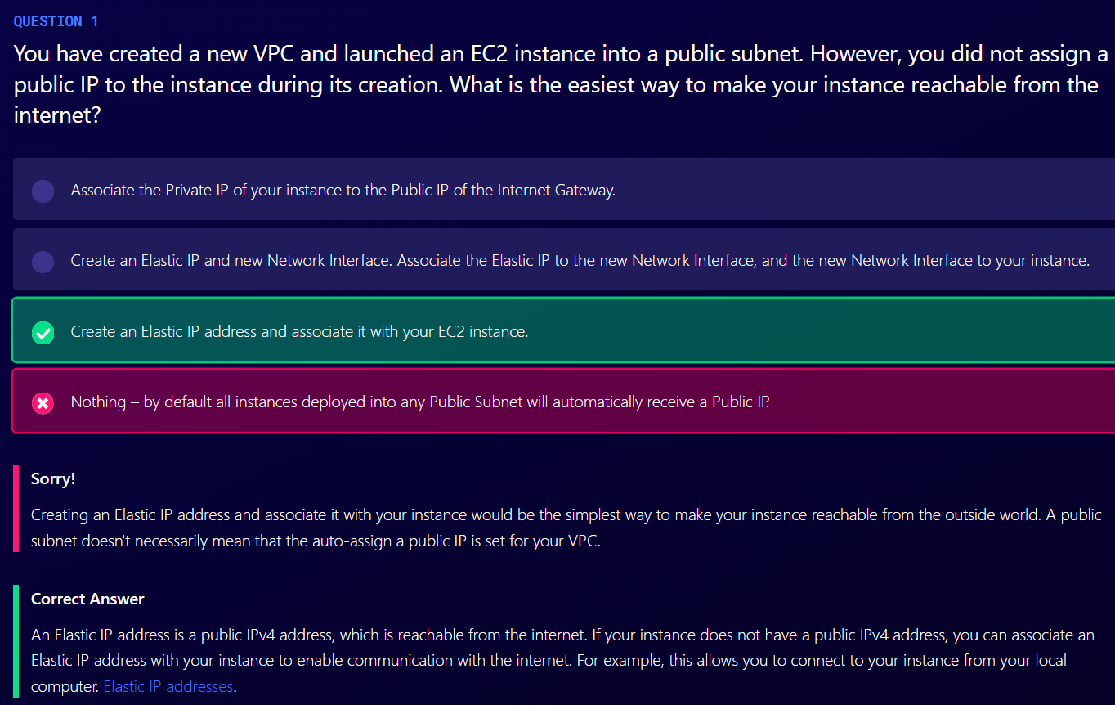

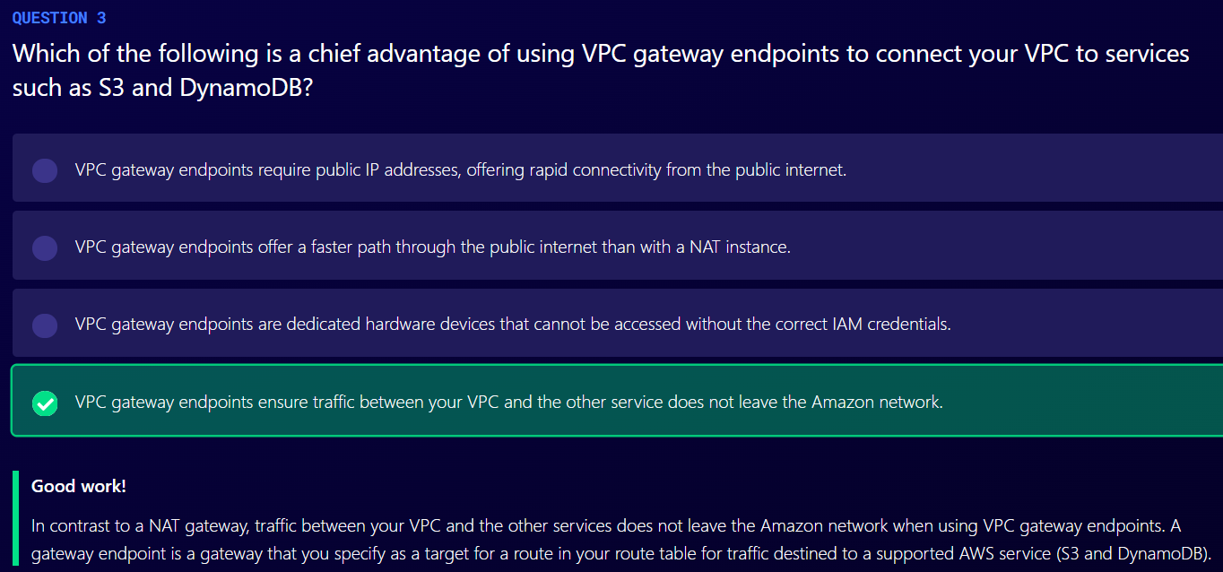

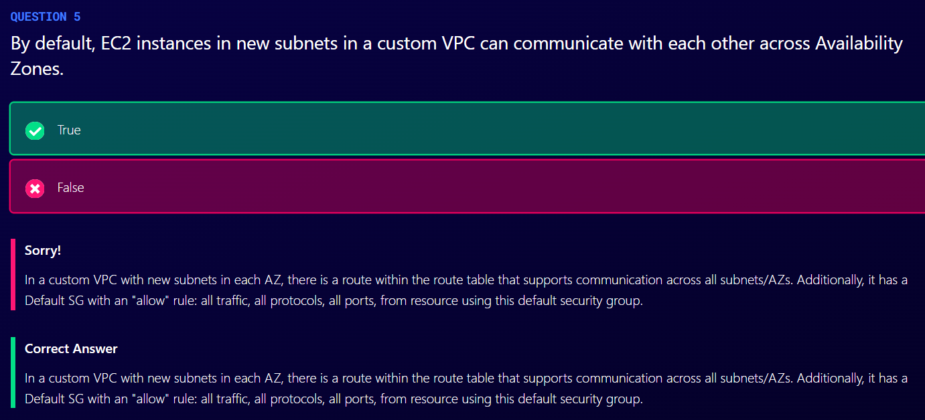

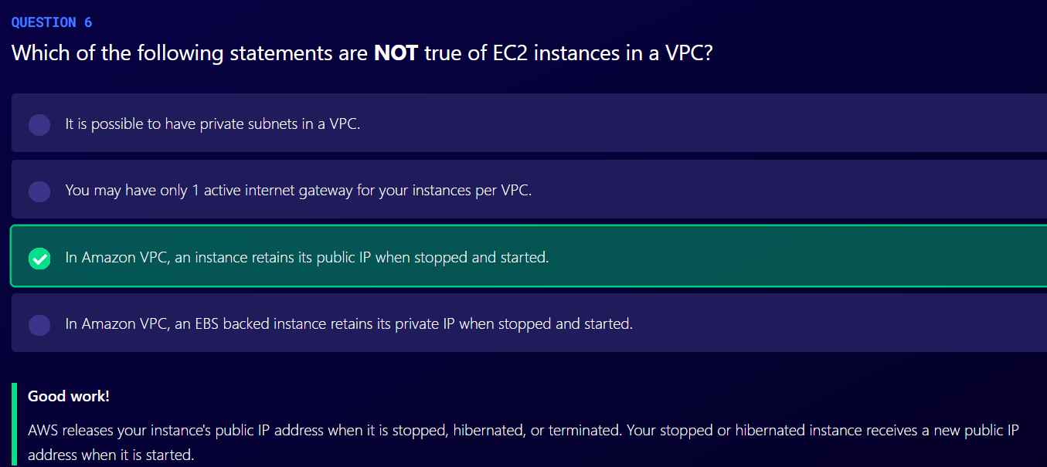

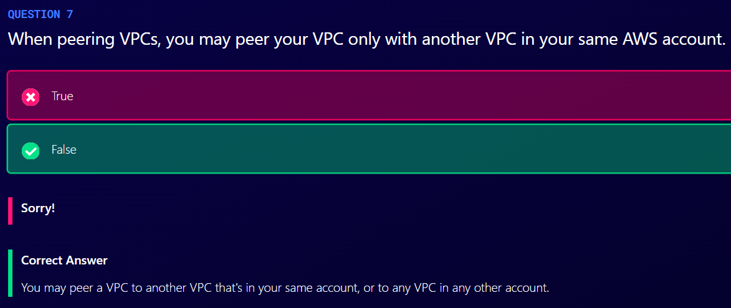

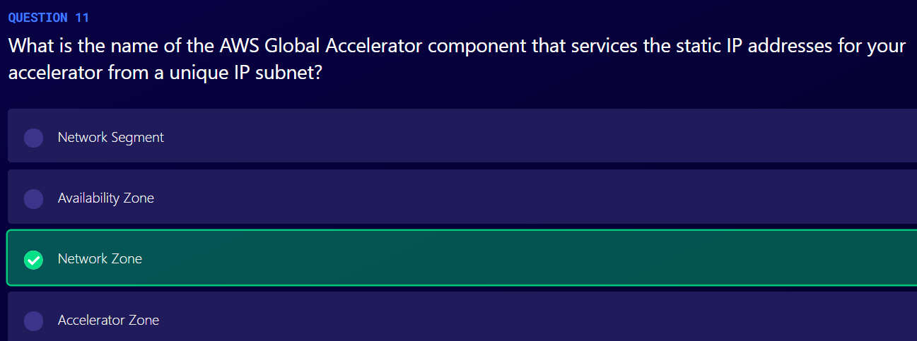

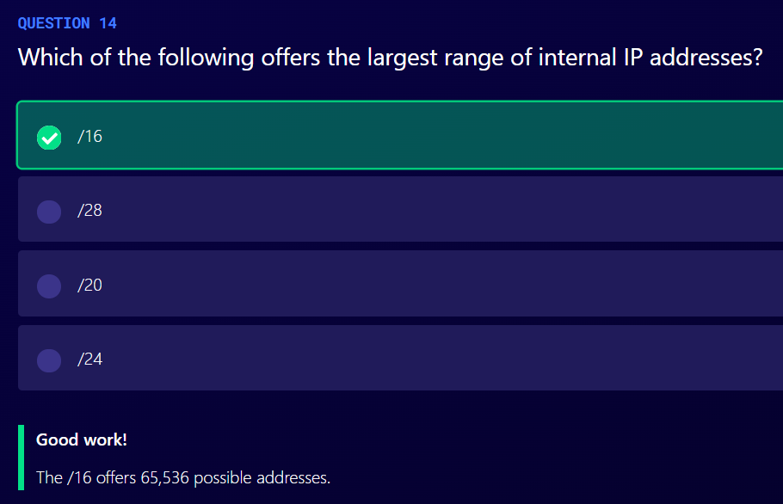

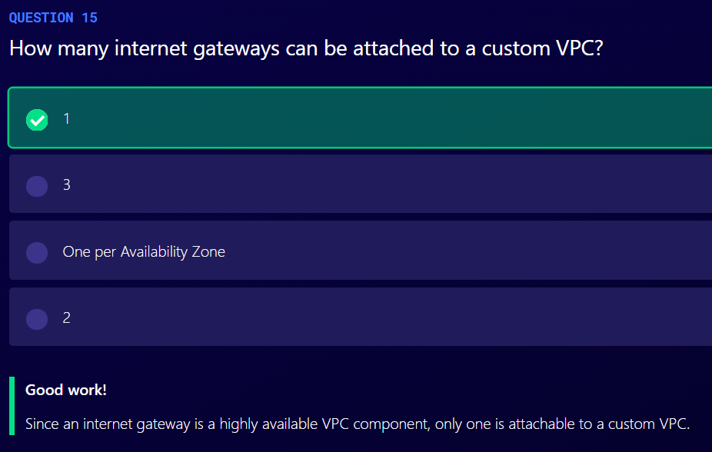

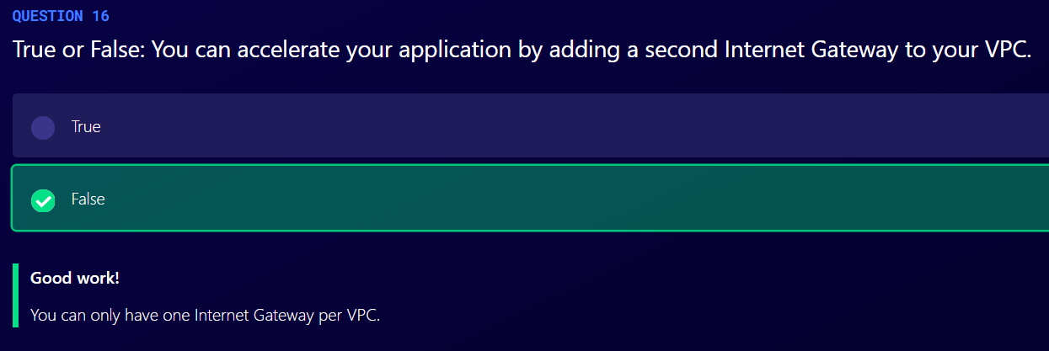

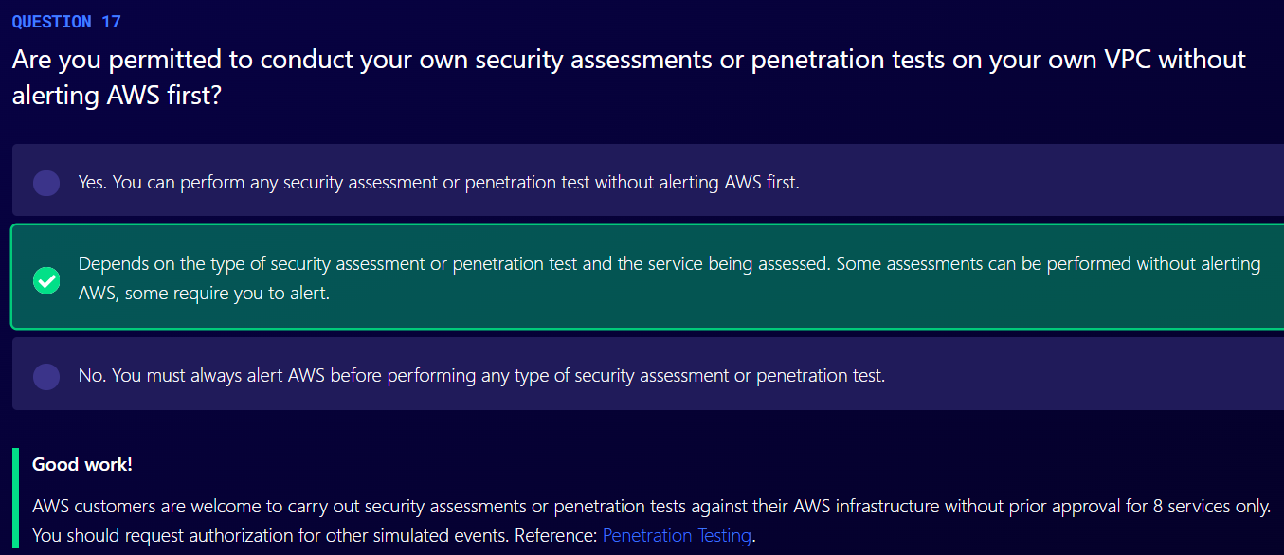

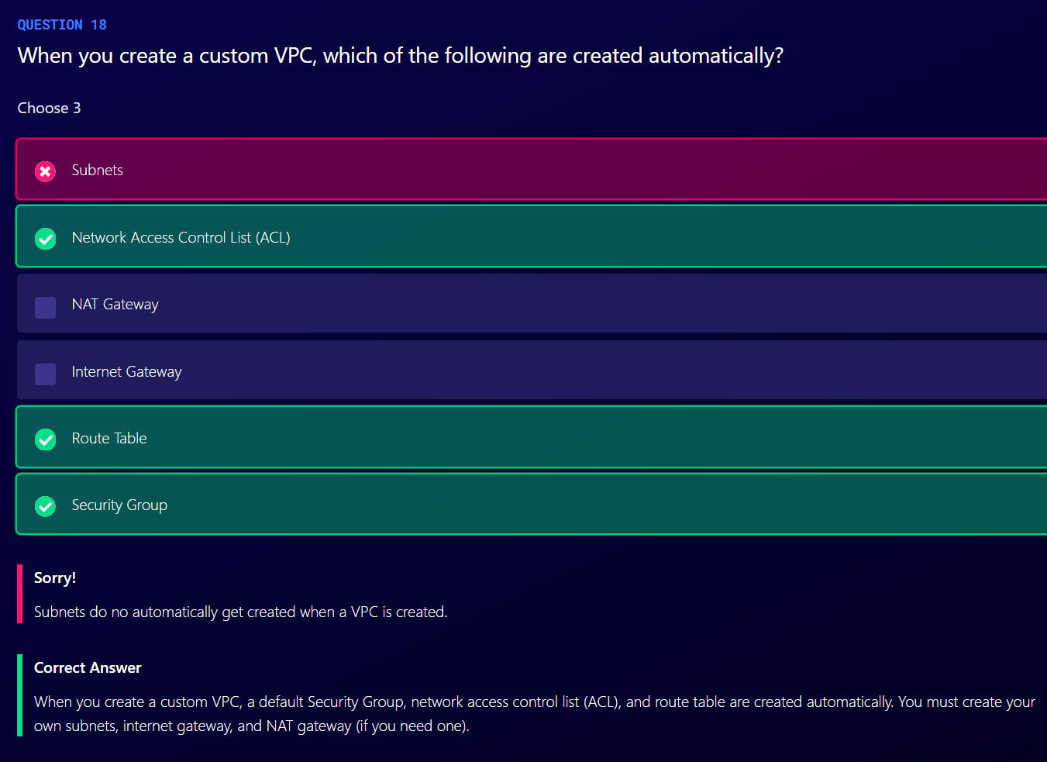

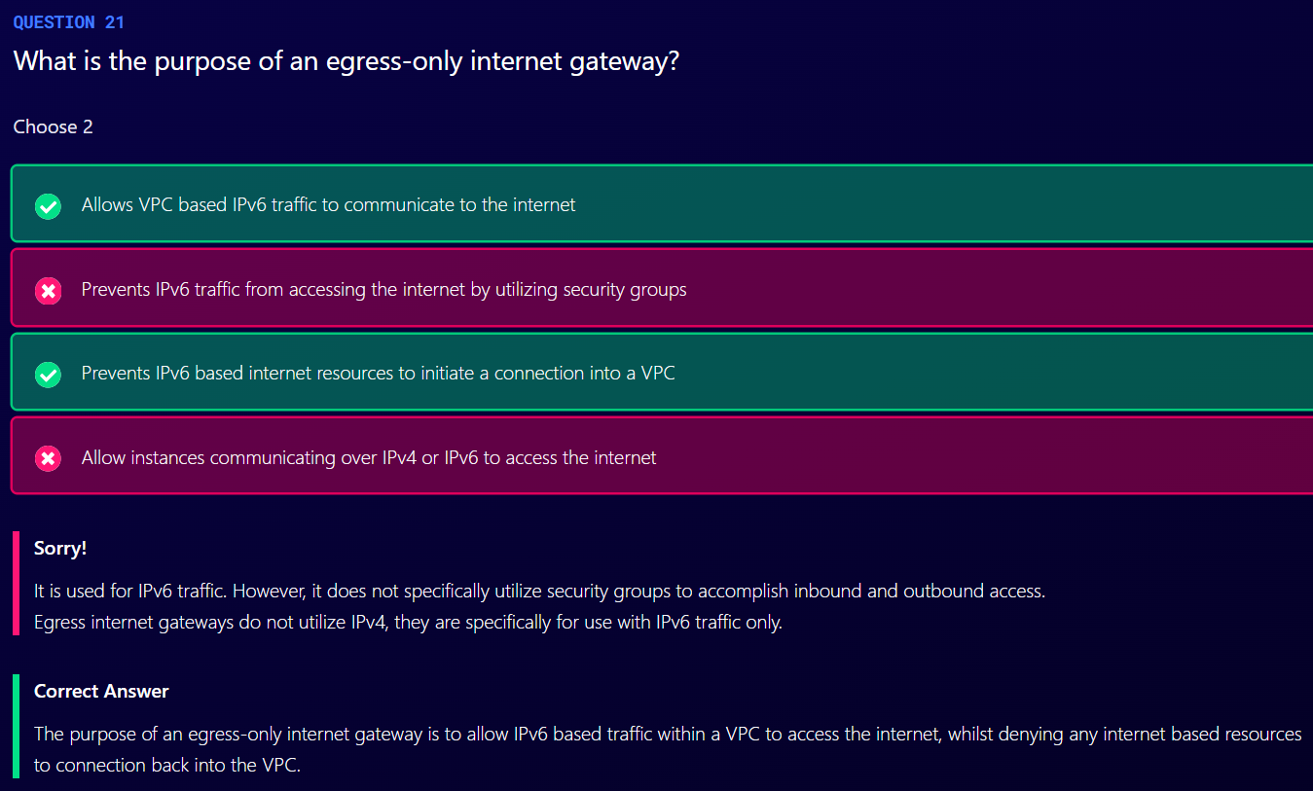

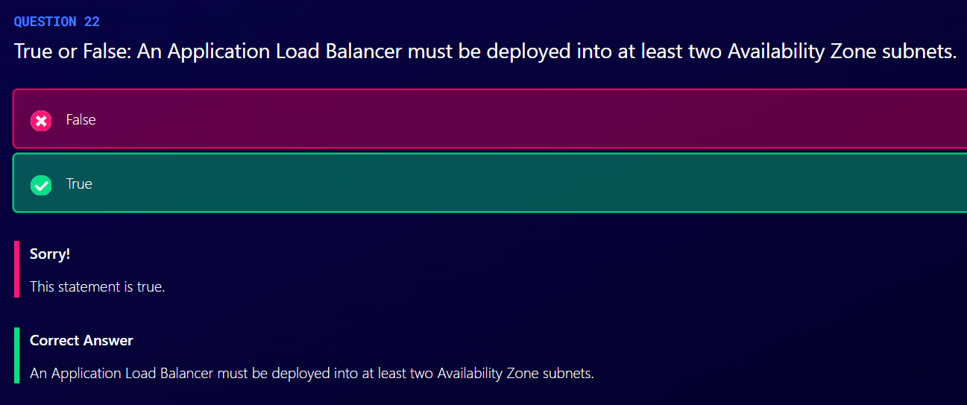

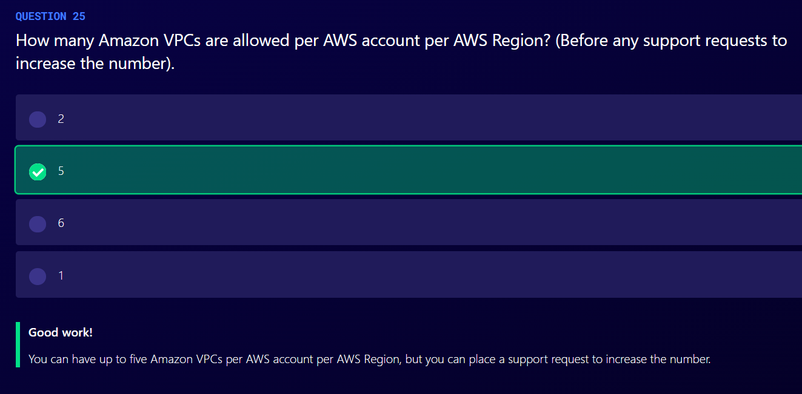

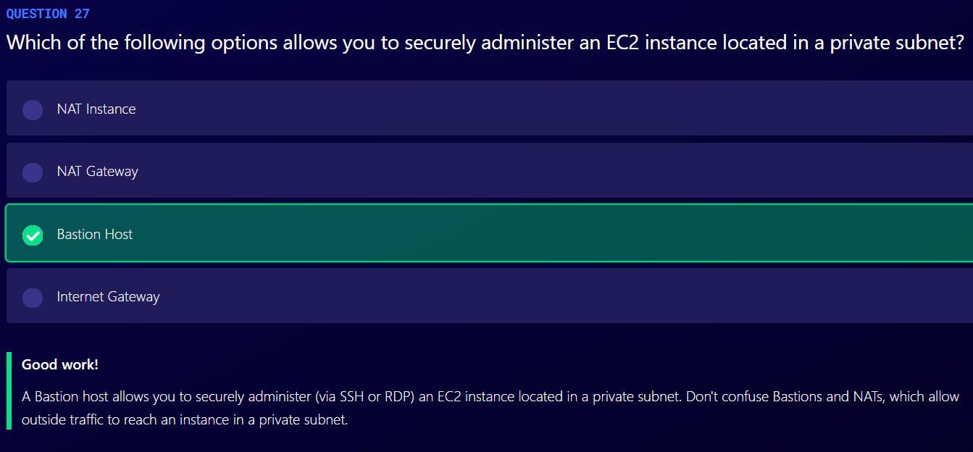

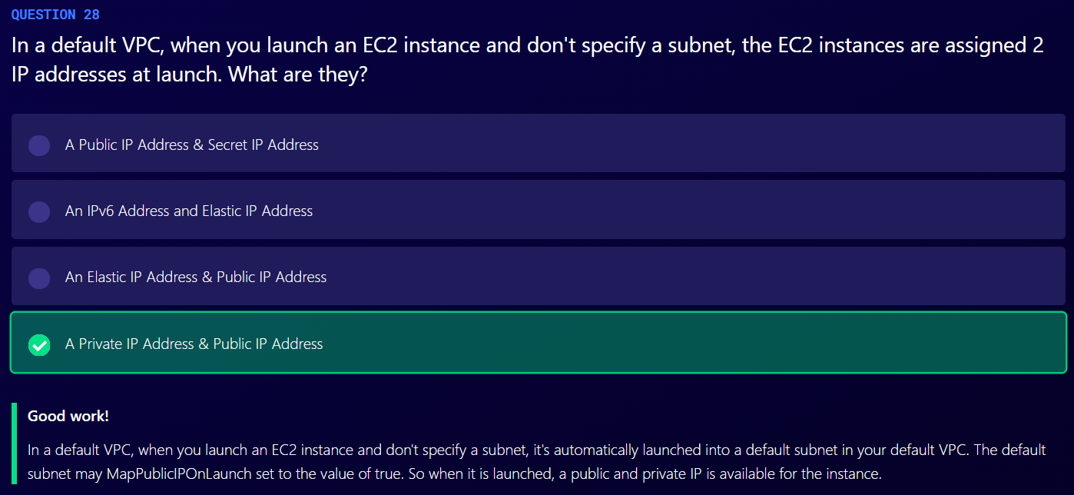

Elastic Load Balancer

1. Application Load Balancer
   1. Load balancing of HTTP and HTTPS traffic
   2. Operate at layer 7
   3. Are application aware
   4. Send specific requests to specific web servers
2. Network Load Balancer
   1. Load balancing of TCP traffic where extreme performance is required
   2. Operate at layer 4
   3. Are capable of handling millions of requests per second while maintaining ultra-low latencies
   4. Used for extreme performance
3. Classic Load Balancer
   1. Operate at layer 7 and 4
   2. If your application stops responding, ELB is going to respond with a 504 error. 504 means gateway timeout and this means that your application is having an issue

Note

If you need the IPv4 address of your end user, look for the X-Forwarded-For header.

Instances monitored by ELB are reported as InService or OutofService.

Health Checks check the instance health by talking to it.

Load balancers have their own DNS name. you are never given an IP address.

Sticky Sessions

1. Classic load balancer routes each request independently to the registered EC2 instance with the smallest load.
2. Sticky sessions allow you to bind a user’s session to a specific EC2 instance. This ensures that all requests from the user during the session are sent to the same instance.
3. You can enable Sticky Sessions for Application Load Balancers as well, but the traffic will be sent at the Target Group Level rather than individual EC2 instance.

Cross Zone Load Balancing

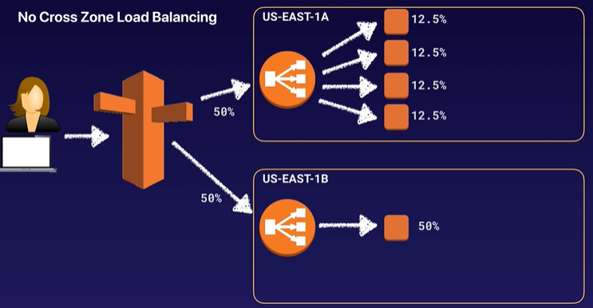

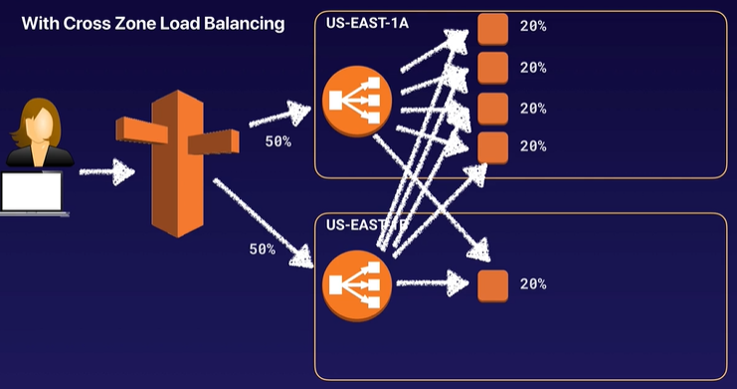

1. Cross Zone Load Balancing enables you to load balance across multiple availability zones.

Path Patterns

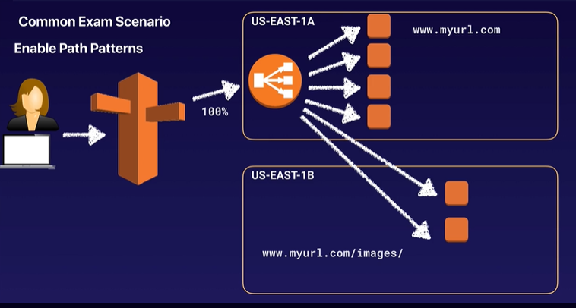

1. Allows you to direct traffic to different EC2 instances based on the URL contained in the request.
2. You can create a listener with rules to forward requests based on the URL path.
3. This is known as path-based routing.
4. If you are running microservices, you can route traffic to multiple back-end services using path-based routing.
5. For example, you can route general requests to one target group and requests to render images to another target group.

Auto Scaling

1. Auto Scaling has 3 components
   1. Groups
      1. Logical component
      2. Webserver group or application group or database group, etc
   2. Configuration Templates
      1. Groups uses a launch template or a launch configuration as a configuration template for its EC2 instances.
      2. You can specify information such as AMI ID, instance type, key pair, security groups, and block device mapping for your instances.
   3. Scaling Options
      1. Provides several ways to scale your Auto Scaling groups
2. Scaling options include
   1. Maintain current instance levels at all times
      1. You can configure your ASG to maintain a specified number of running instances at all times
      2. To maintain the current instance levels, Amazon EC2 Auto Scaling performs a periodic health check on running instances within an ASG
      3. When Amazon EC2 Auto Scaling finds as unhealthy instance, it terminates that instance and launches a new one
   2. Scale manually
      1. Manually change number of instances in ASG
   3. Scale based on a schedule
      1. Scaling actions are performed automatically as a function of time and date
   4. Scale based on demand
      1. Lets you define parameters that control the scaling process
      2. Suppose you want CPU Utilization of ASG to stay at around 50 percent when the load on application changes
   5. Use predictive scaling
      1. Make prediction based on previous performance

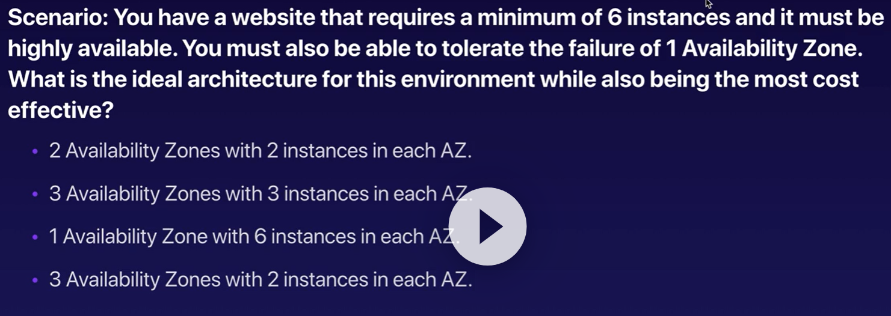

3 AZ with 3 instances in each AZ

There should always be 6 instances running

CloudFormation

1. Is a way of completely scripting your cloud environment
2. Quick Start is a bunch of CloudFormation templates already built by AWS Solutions Architects allowing you to create complex environments very quickly

High Availability with Bastion Hosts

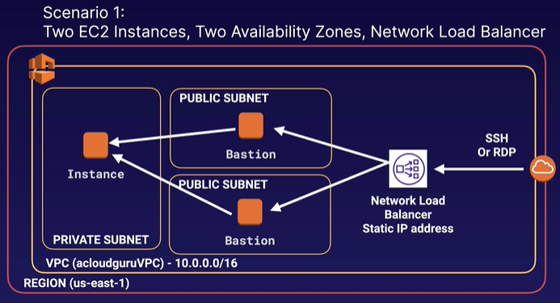

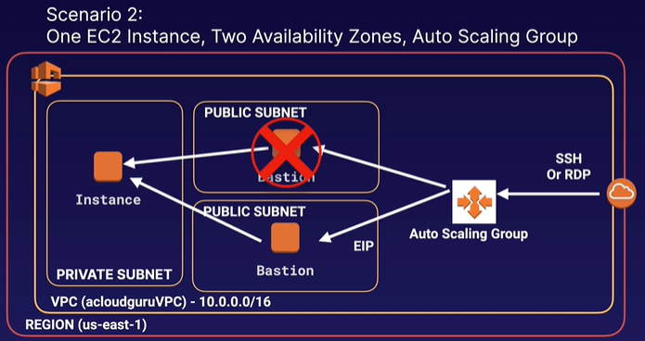

1. Scenario 1
   1. 2 EC2 Instances, 2 AZ, Network Load Balancer
   2. Two hosts in two separate AZ. Use a Network Load Balancer with static IP addresses and health checks to fail over from one host to the other
   3. Can’t use an Application Load Balancer, as it is layer 7 and you need to use layer 4
2. Scenario 2
   1. 1 EC2 Instance, 2 AZ, ASG
   2. One host in one AZ behind an ASG with health checks and a fixed EIP.
   3. If the host fails, the health check will fail and the ASG will provision a new EC2 instance in a separate AZ.
   4. Cheapest but is not 100% fault tolerant. There might be some down time while new instance is being provisioned.

On-premises Services with AWS

1. AWS services that you can use on-premises are
   1. Database Migration Service (DMS)
   2. Server Migration Service (SMS)
   3. AWS Application Discovery Service
   4. VM Import/Export
      1. Migrate existing applications in to EC2
      2. Can be used to create a DR strategy on AWS or use AWS as a second site
      3. You can also use it to export your AWS VMs to your on-premises data center
   5. Download Amazon Linux 2 as an ISO
      1. AWS allows you to download Amazon Linux 2 as an ISO
      2. Works with all major virtualization providers, such as VMware, Hyper-V, KVM, VirtualBox (Oracle), etc

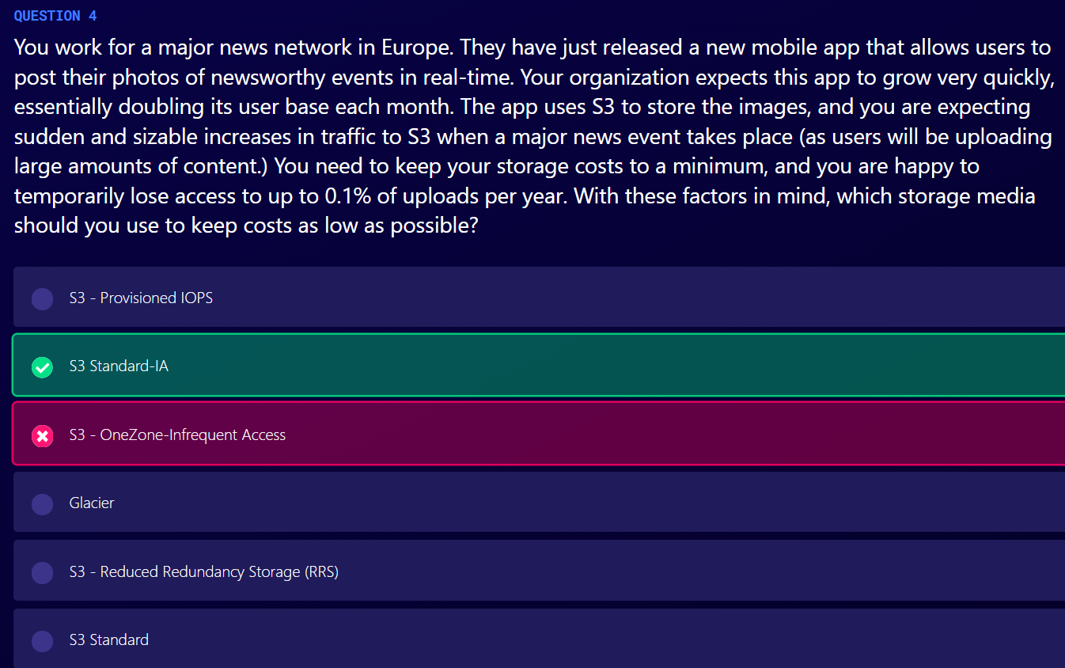

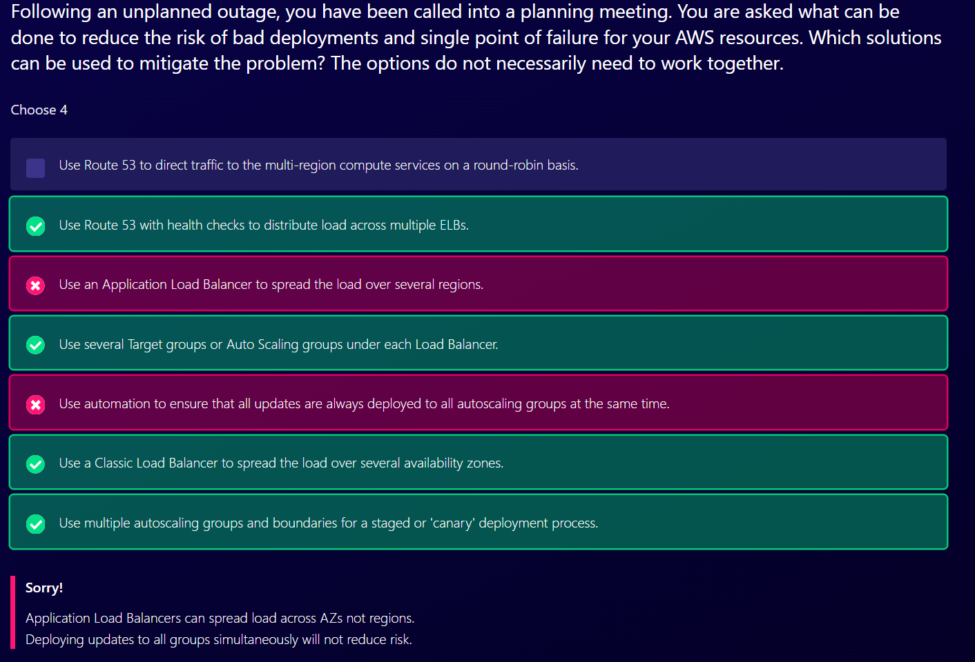

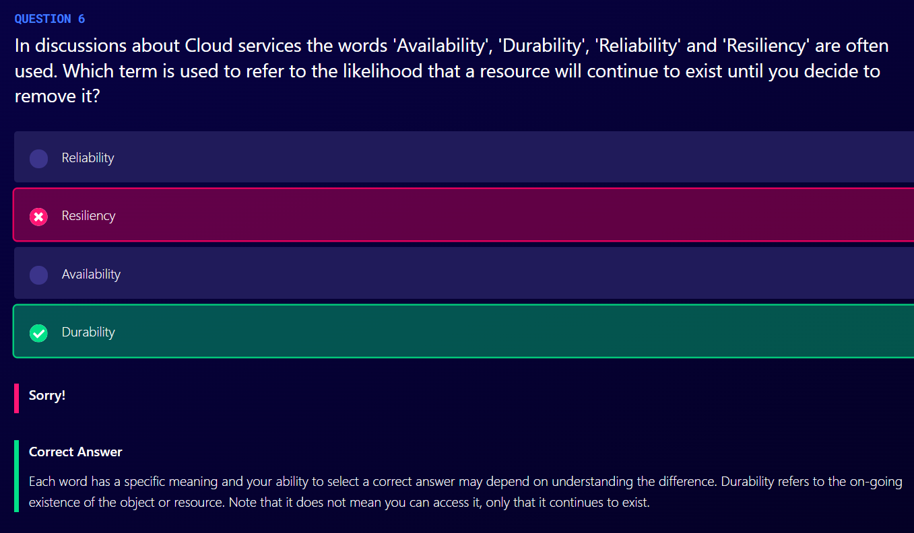

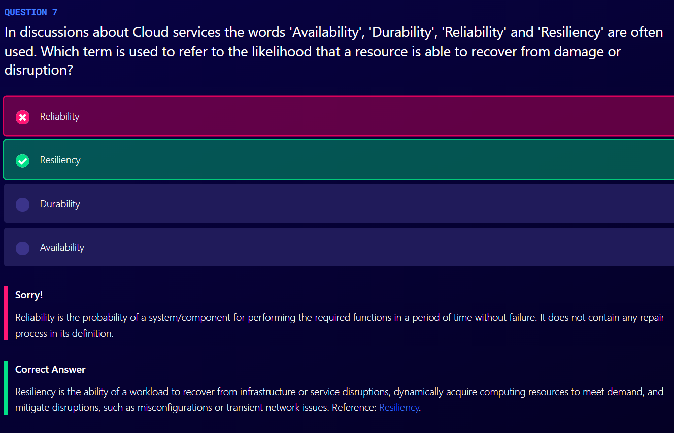

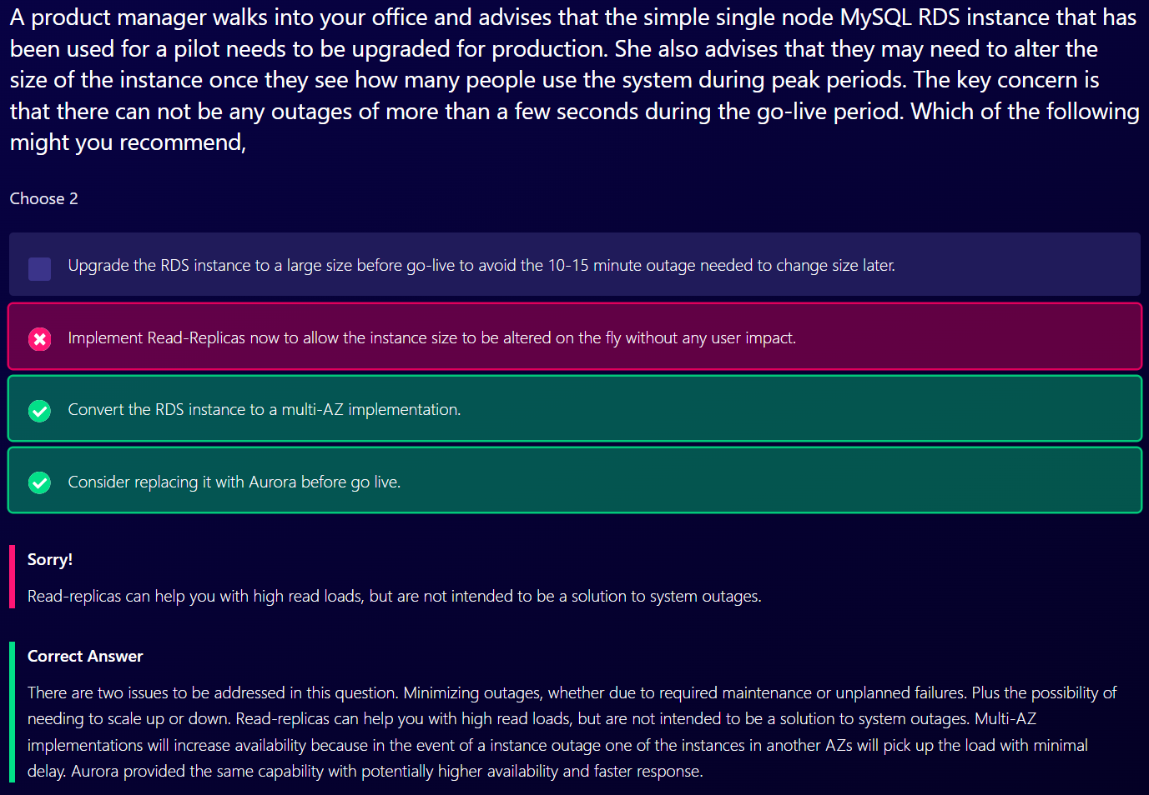

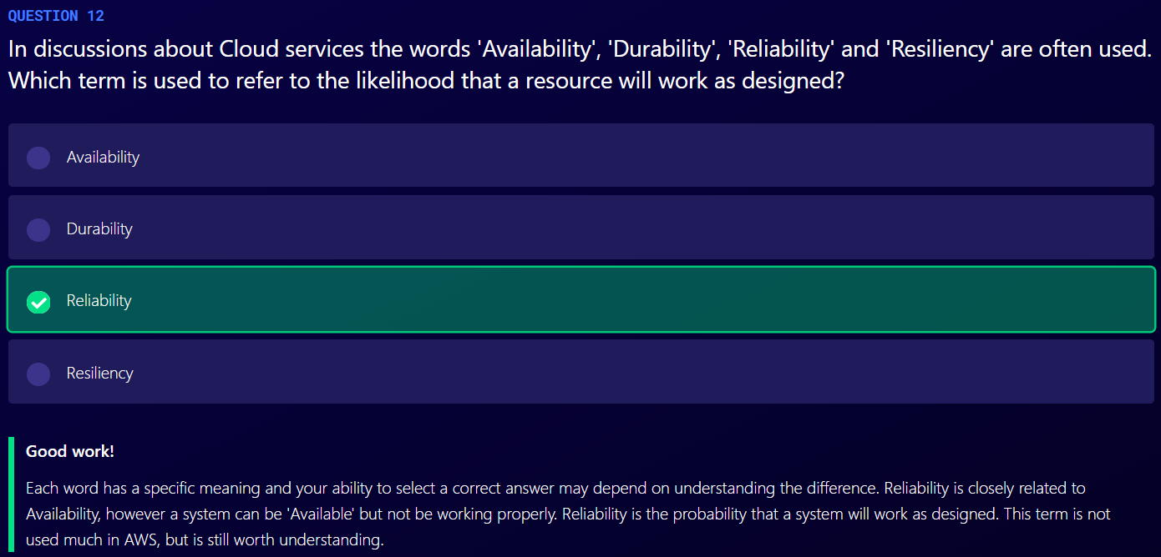

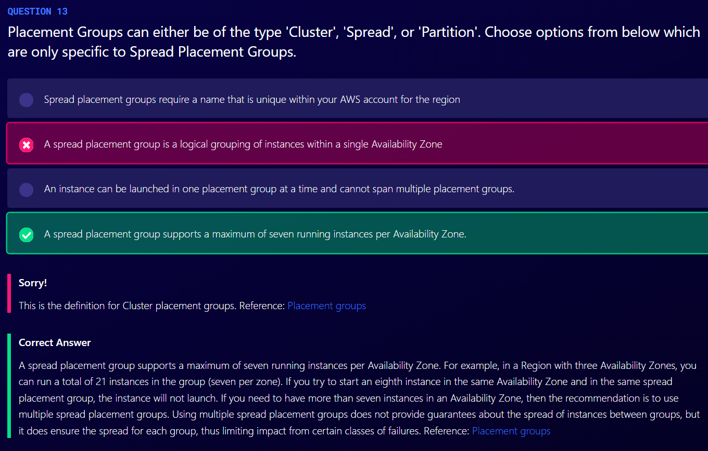

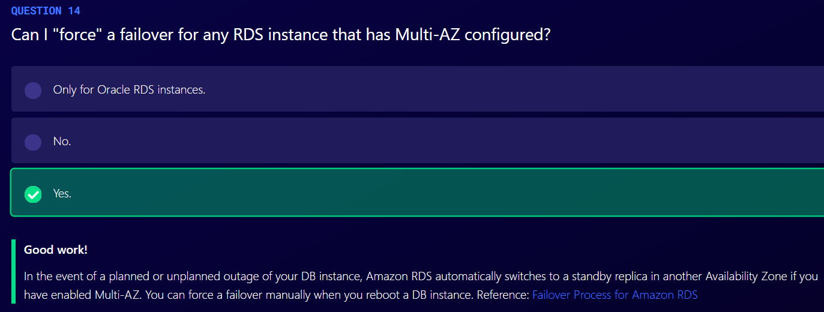

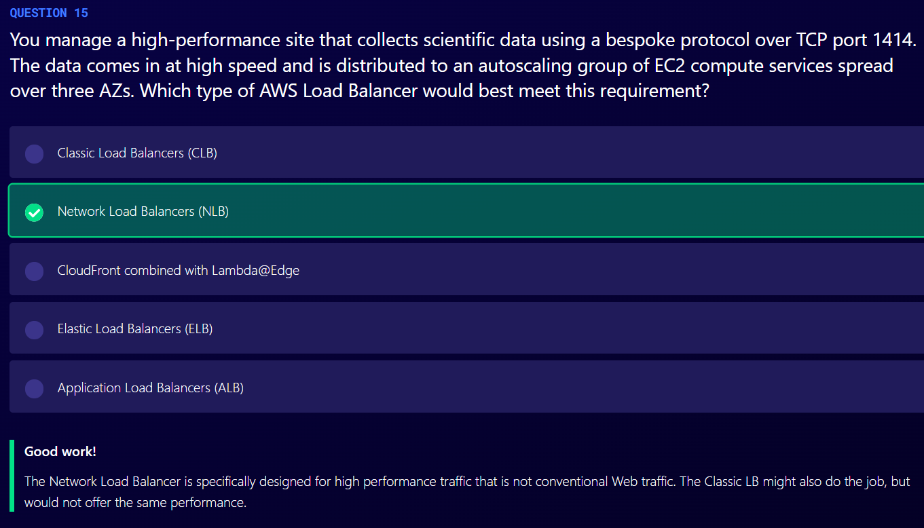

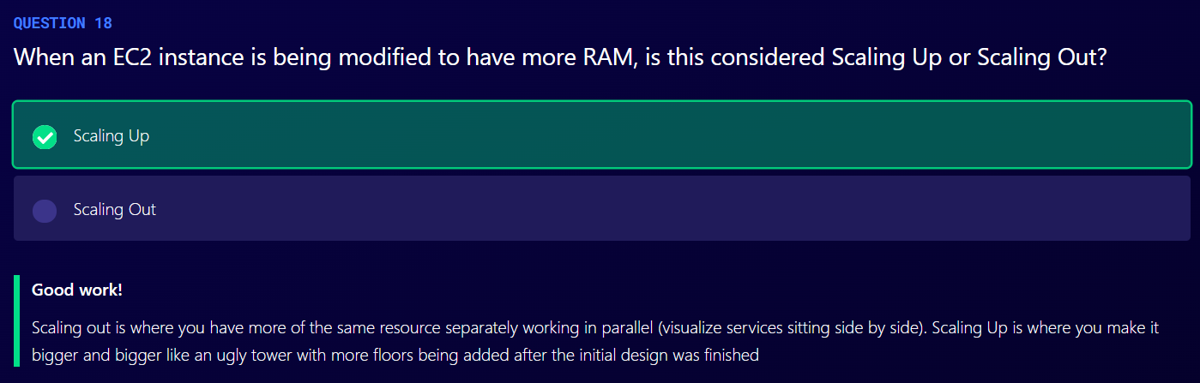

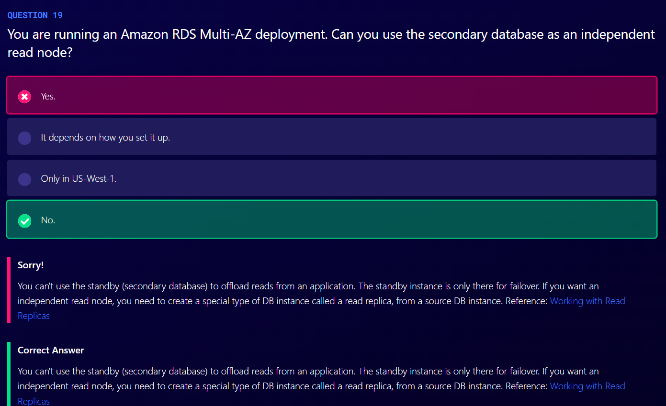

SQS

1. Way to decouple your infrastructure
2. SQS is pull-based, not push based. We should have EC2 Instance polling the queue.
3. Messages can be 256 KB in size or less.
4. Messages can be kept in the queue from 1 minute to 14 days; the default retention period is 4 days.
5. There are two types of queues
   1. Standard queues (default)
      1. SQS offers standard queue as the default queue type.
      2. A standard queue lets you have a nearly unlimited number of transactions per second.
      3. Guarantees that a message is delivered at least once
      4. Occasionally, more than one copy of a message might be delivered out of order
      5. They provide best-effort ordering which ensures that messages are generally delivered in the same order as they are sent
   2. FIFO queue
      1. The order in which messages are sent and received is strictly preserved and a message is delivered once and remains available until a consumer processes and deletes it
      2. Duplicates are not introduced into the queue
      3. Supports message groups that allow multiple ordered message groups within a single queue.
      4. FIFO queues are limited to 300 transactions per second (TPS), but have all the capabilities of standard queues
6. Visibility timeout is the amount of time that the message is invisible in the SQS queue after a reader picks up that message. Provided the job is processed before the visibility timeout expires, the message will then be deleted from the queue. If the job is not processed within that time, the message will become visible again and another reader will process it. This could result in same message being delivered twice.
7. Visibility timeout maximum is 12 hours.
8. SQS guarantees that messages will be processed at least once.
9. Amazon SQS long polling is a way to retrieve messages from your Amazon SQS queues. While the regular short polling returns immediately (even if the message queue being polled is empty), long polling does not return a response until a message arrives in the message queue or the long poll times out.

SWF (Simple Workflow Service)

1. Ensures that a task is assigned only once and is never duplicated
2. Keeps track of all the tasks and events in an application
3. Offers task-oriented API
4. Workflow executions can last upto 1 year
5. SWF Actors
   1. Workflow Starters
      1. An application that can initiate (start) a workflow.
   2. Deciders
      1. Controls the flow of activity tasks in a workflow execution
      2. If something has finished (or failed) in a workflow, a decider decides what to do next.
   3. Activity Workers
      1. Carry out activity tasks

SWF vs SQS

1. SQS has a retention period of up to 14 days; with SWF, workflow executions can last up to 1 year
2. Amazon SWF presents a task-oriented API, whereas Amazon SQS offers a message-oriented API
3. Amazon SWF ensures that a task is assigned only once and is never duplicated. With Amazon SQS, you need to handle duplicated messages and may also need to ensure that a message is processed only once.
4. Amazon SWF keeps track of all the tasks and events in an application. With Amazon SQS, you need to implement your own application-level tracking, especially if your application uses multiple queues.

SNS

1. SNS is push based delivery service (no polling)
2. To prevent messages from being lost, all messages published to SNS are stored redundantly across multiple AZ

Elastic Transcoder

1. Convert media files form their original source format in to different formats that will play on smartphones, tablets, PCs, etc.
2. Pay based on minutes that you transcode and the resolution at which you transcode

API Gateway

1. Acts as a “front door” for applications to access data, business logic or functionality from your back-end services, such as applications running on Amazon EC2, code running on AWS Lambda or any web application.
2. API Gateway can do following things:
   1. Expose HTTPS endpoints to define a RESTful API
   2. Serverless-ly connect to services like Lambda and DynamoDB
   3. Send each API endpoint to a different target
   4. Run efficiently with low cost
   5. Scales automatically
   6. Track and control usage by API key
   7. Throttle requests to prevent attacks
   8. Connect to CloudWatch to log all requests for monitoring
   9. Maintain multiple versions of your API
3. API Gateway Caching
   1. You can enable API caching in Amazon API Gateway to cache your endpoint’s response.
   2. With caching, you can reduce the number of calls made to your endpoint and also improve the latency of the requests to your API
   3. When you enable caching for a stage, API Gateway caches responses from your endpoint for a specified time-to-live (TTL) period, in seconds.
   4. API Gateway then responds to the request by looking up the endpoint response from the cache instead of making a request to your endpoint.
4. Same Origin Policy
   1. Under this policy, a web browser permits scripts contained in a first web page to access data in a second web page, but only if both web pages have the same origin.
   2. This is done to prevent Cross-Site Scripting (XSS) attacks.
   3. This is enforced by web browsers and ignored by tools like Postman and curl
5. CORS (Cross Origin Resource Sharing)
   1. It is being able to talk to a web page in another domain and request resources from it
   2. If we get error saying Origin Policy cannot be read at the remote resource, you need to enable CORS on API Gateway
   3. CORS is always enforced by client’s browser

Streaming Data

1. Data that is generated continuously by thousands of data sources, which typically send in the data records simultaneously, and in small sizes (order of KB).

Kinesis

1. Makes it easy to load and analyze streaming data, and also providing the ability for you to build your own custom applications for your business needs.
2. Types of Kinesis
   1. Kinesis Streams
      1. A place to store data produced by producers.
      2. Data is persistent.
      3. By default, data is stored for 24 hours. However, it can store it up to 7 days.
      4. Data is contained in shards
      5. Kinesis Streams consist of shards
         1. 5 transactions per second for reads, up to a maximum total data read rate of 2MB per second and up to 1,000 records per second for writes, up to a maximum total data write rate of 1 MB per second
         2. The data capacity of your stream is a function of number of shards that you specify for the stream. The total capacity of stream is the sum of capacities of its shards.
   2. Kinesis Firehouse
      1. There is no data persistence.
      2. Data should be analyzed as soon as it comes into Kinesis Firehouse using lambda.
   3. Kinesis Analytics
      1. Analyze your data inside Kinesis Streams and Kinesis Firehouse.
      2. It works with Kinesis Streams and Kinesis Firehouse

Web Identity Federation and Cognito

1. Web Identity Federation is when you try to sign in to a website using Facebook credentials, Google credentials

Cognito

1. Cognito provides Web Identity Federation with the following features
   1. Sign-up and sign-in to your apps
   2. Access for guest users
   3. Acts as an identity broker between your application and Web ID providers so you don’t need to write any additional code
   4. Synchronizes user data for multiple devices
   5. Recommended for all mobile applications AWS services

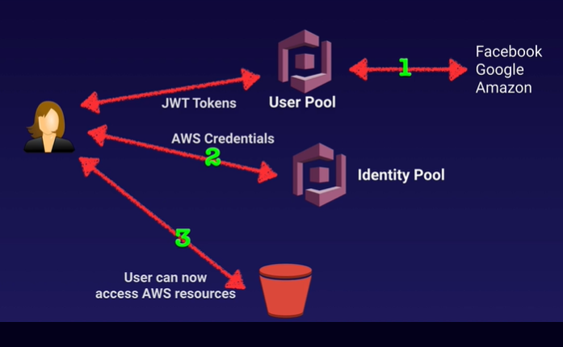

Cognito User Pools

1. User pools are user directories used to manage sign-up and sign-in functionality for mobile and web applications.
2. Users can sign-in directly to User Pool, or using Facebook, Amazon, or Google.
3. Cognito acts as an Identity Broker between the identity provider and AWS.
4. Successful authentication generates a JSON Web Token (JWTs).
5. User pool is user based. It handles things like user registration, authentication and account recovery.

Cognito Identity Pools

1. Identity pools enable provide temporary AWS credentials to access AWS services like S3 or DynamoDB
2. It is all about authorization of all the access to AWS resources whereas User Pools is all about your actual users

Cognito Synchronization

1. Cognito tracks the association between user identity and various different devices they sign-in from.
2. In order to provide seamless user experience for your application, Cognito uses Push Synchronization to push updates and synchronize user data across multiple devices
3. Cognito uses SNS to send a notification to all the devices associated with a given user identity whenever data stored in the cloud changes

Event Processing Patterns

Dead Letter Queue (DLQ)

1. There are three different services in AWS that use dead letter queue
   1. SNS: messages published to a topic that fail to deliver are sent to an SQS queue; held for further analysis or reprocessing
   2. SQS: messages sent to SQS that exceed the queue’s maxReceiveCount are sent to a DLQ
   3. Lambda: result from failed asynchronous invocations; will retry twice and send to either an SQS queue or SNS topic

S3 Event Notifications

1. Object Created
2. Object removed
3. Object Restored
4. RRS Object loss
5. Replication

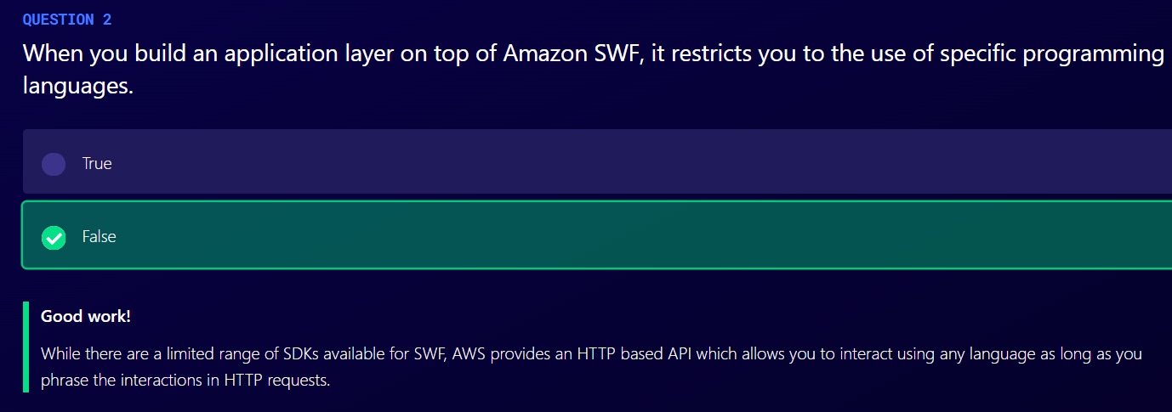

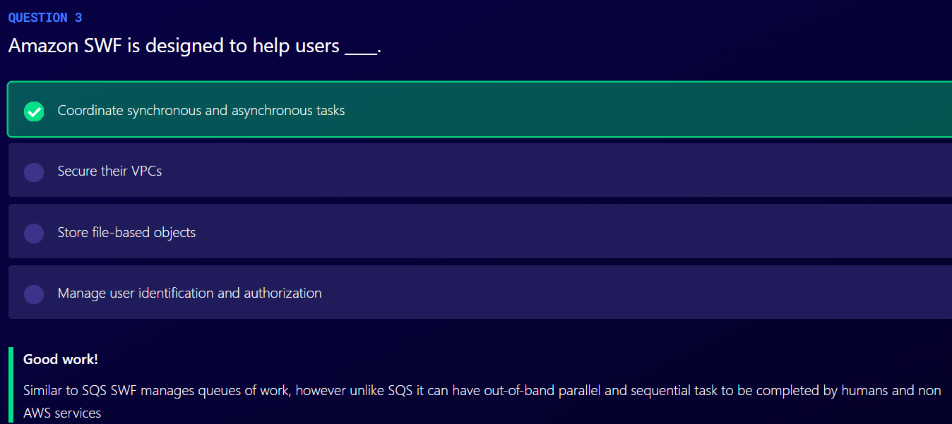

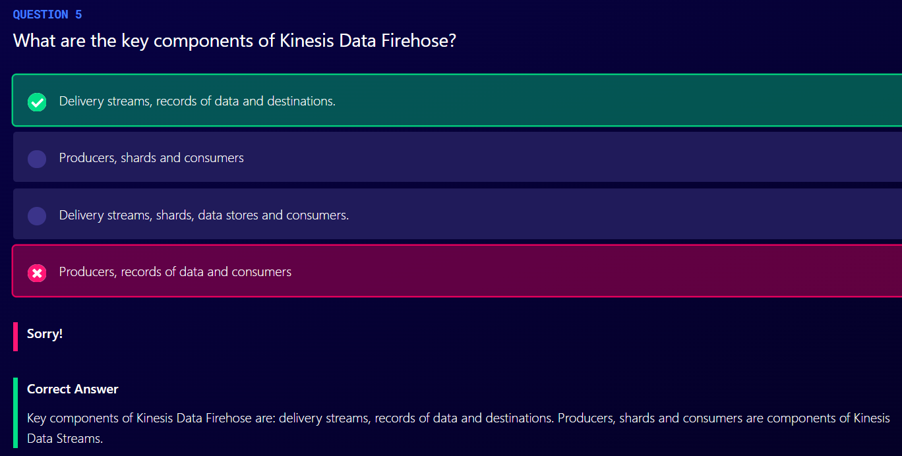

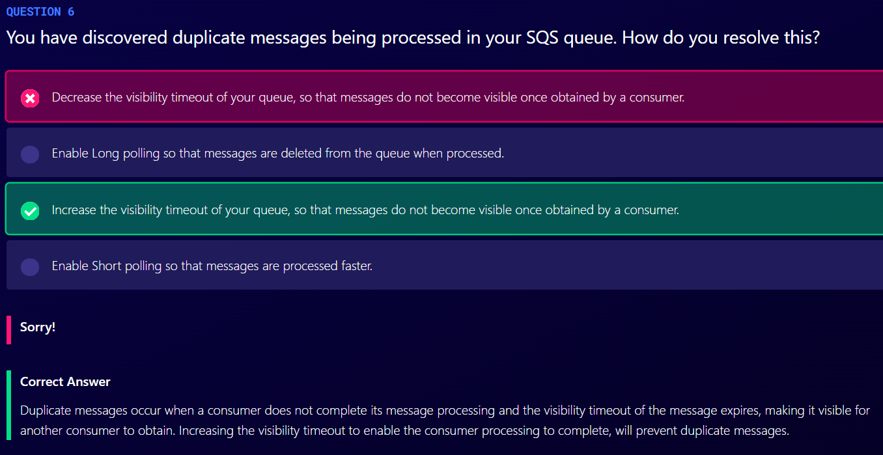

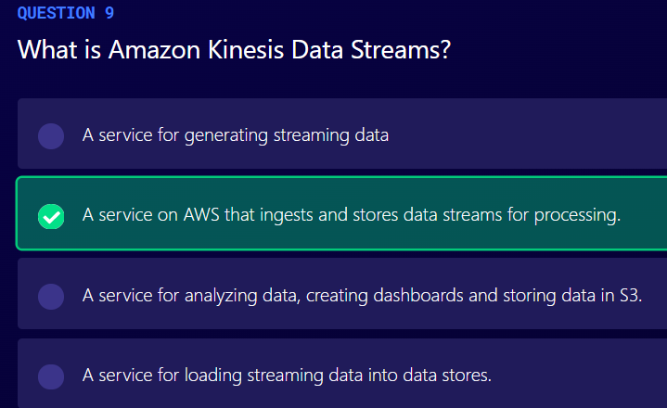

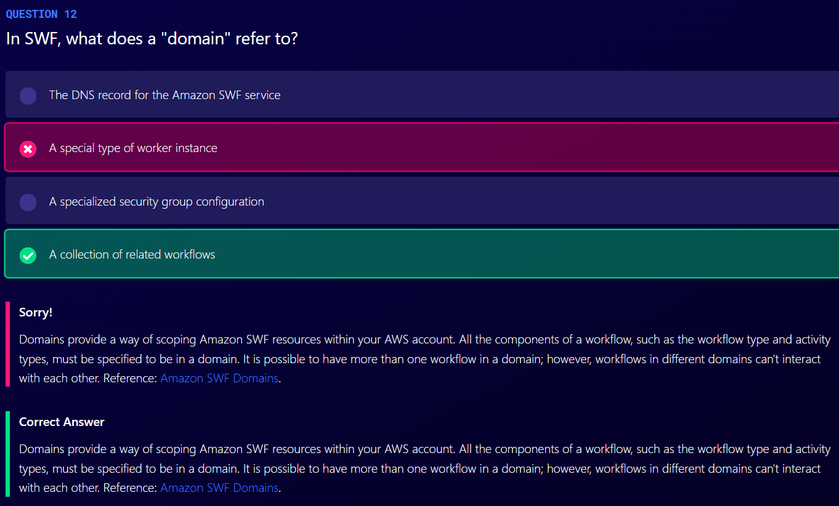

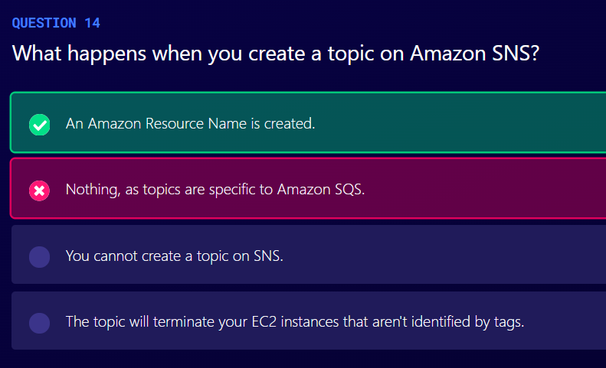

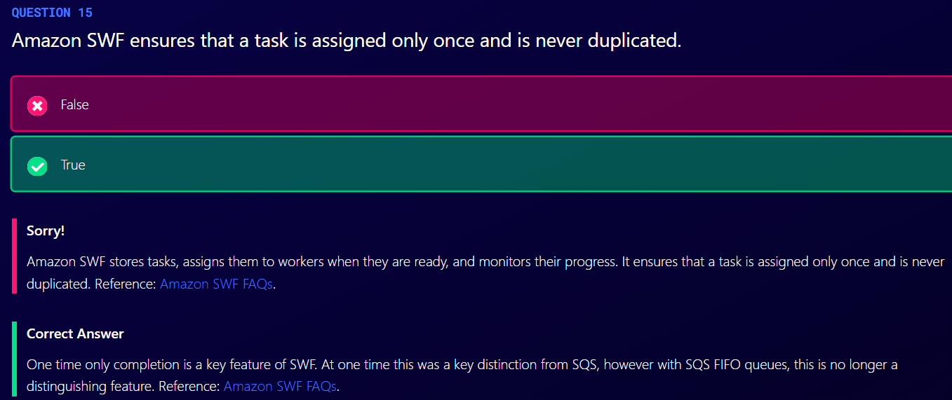

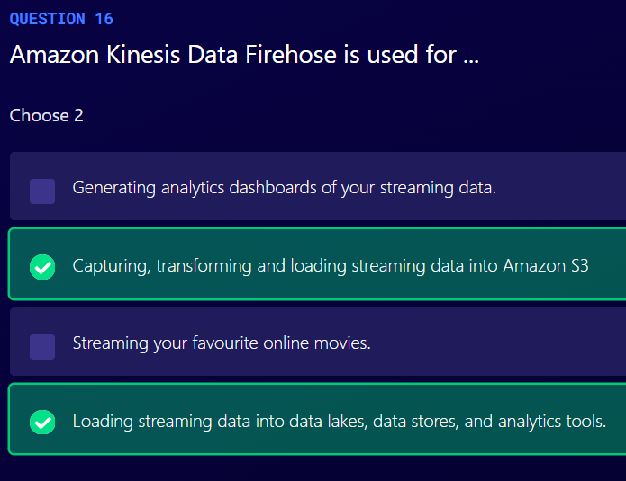

KMS (Key Management Service)

1. Manages Customer Master Keys (CMK)
2. Encrypt and decrypt data up to 4KB in size
3. Integrated with most AWS services
4. Pay per API call
5. Audit capability using CloudTrail- logs delivered to S3
6. FIPS 140-2 level 2

Types of CMKs

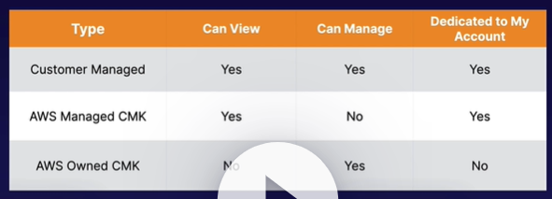

1. AWS Managed CMK
   1. Free
   2. Are created automatically when you first create an encrypted resource in an AWS service
2. Customer Managed CMK
   1. Gives you full control over the lifecycle and permissions that determine who can use the key and under which conditions
   2. Allows key rotation
3. AWS Owned CMK
   1. Used by AWS on a shared basis across many accounts; you typically won’t see these

Symmetric vs Asymmetric CMK

1. Symmetric CMK
   1. When you create a customer master key in KMS, by default, you get a symmetric CMK
   2. Same key is used for both encryption and decryption
   3. Encryption algorithm is based on AES-256
   4. Must call the KMS APIs to use
   5. AWS services integrated with KMS use symmetric CMKs
   6. They can be used to encrypt, decrypt, and re-encrypt data, generate data keys, data key pairs and random byte strings
   7. They can also be used to import your own key material
2. Asymmetric CMK
   1. Private/public key pair
   2. Based on RSA and elliptic-curve cryptography (ECC)
   3. Private key never leaves AWS unencrypted
   4. Must call the KMS APIs to use private key
   5. Public key can be downloaded and used outside AWS
   6. These are most often used outside if AWS by users who cannot call KMS APIs
   7. AWS services integrated with KMS do not support asymmetric CMKs
   8. They are often used to sign messages and verify signatures

CloudHSM

1. Dedicated hardware security module (HSM)
2. FIPS 140-2 Level 3
3. Manage your own keys
4. Runs within a VPC in your account
5. Is a single tenant dedicated hardware solution that runs in a multi AZ cluster for high availability
6. Works with industry standard PIS
7. There are no AWS APIs available for CloudHSM
8. Keep your keys safe – irretrievable if lost

System Manager Parameter Store

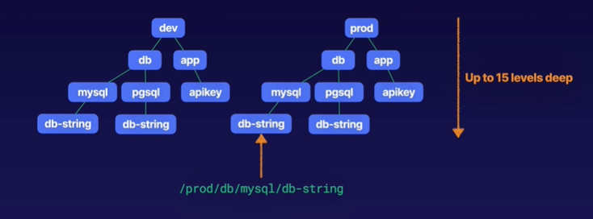

1. Central tool for caching and distributing secrets securely to AWS resources
2. Serverless scalable and high performance system for storing data and storing secrets like passwords, database connection strings, license codes, API keys
3. Values can be stored encrypted (KMS) or plaintext
4. It has ability to store parameters in hierarchies. This hierarchy can be upto 15 levels deep.
5. GetParametersByPath API can be used to retrieve all parameters in a hierarchy
6. We can also track versions of values in parameter store
7. You can also set TTL or time to live, to expire certain types of values such as passwords which enables you to enforce password rotation

Secrets Manager

1. Service that helps you to rotate, amange and retrieve all kinds of secrets like database credentials, API keys and so on.
2. Similar to Systems Manager Parameter Store
3. Parameter store comes with no additional charges. There is limit on the number of parameters you can store and that limit is 10,000
4. Secret Manager does come with additional cost
5. Secrets Manager can automatically rotate secrets while parameter store cannot
6. Secrets Manager has ability to generate random passwords while parameter store cannot

AWS Shield

1. Protects against DDOS attacks
2. Two tiers of AWS Shield
   1. AWS Shield Standard
      1. Automatically enabled for all customers at no cost
      2. Protects against common layer 3 and 4 attacks
         1. SYN/UDP floods
         2. Reflection attacks
   2. AWS Shield Advanced
      1. $3,000 per month per organization
      2. Enhanced protection for EC2, ELB, CloudFront, Global Accelerator, Route 53
      3. Business and Enterprise support customers get 24X7 access to the DDoS Response Team (DRT)
      4. DDoS cost protection- this is the form of insurance against any attacks that would otherwise result to your AWS bill

WAF (Web Application Firewall)

1. Lets you monitor HTTP or HTTPS requests to CloudFront, ALB or API Gateway
2. Control access to content
3. We can configure filtering rules to allow/deny traffic based on IP addresses, Query string parameters
4. Protects against SQL query injection
5. If traffic is blocked by WAF, it returns HTTP 403 forbidden error
6. WAF allows three different behaviors
   1. Allow all requests, except the ones you specify
   2. Block all requests, except the ones you specify
   3. Count the requests that match the properties you specify
   4. Request properties
      1. Originating IP address
      2. Originating country
      3. Request size
      4. Values in request headers
      5. Strings in request matching regular expressions (regex) patterns
      6. SQL code (injection)
      7. Cross-Site Scripting (XSS)

AWS Firewall Manager

1. Centrally configure and manage firewall rules across an AWS Organizations
2. Using this, you can deploy WAF rules for your ALB, API Gateway or CloudFront distributions
3. You can also create AWS Shield Advanced Policies to automatically discover resources like ALB, ELB CLB, Elastic IPs, CloudFront Distributions
4. You can also use AWS Firewall to configure security groups across multiple accounts in your AWS organization and continuously audit them to detect overly permissive or misconfigured rules that apply to EC2 instances and Elastic Network Interfaces (ENIs)

Lambda

1. Serverless compute service where you can upload your code and create a lambda function
2. You can use lambda in the following ways
   1. As an event-driven compute service where AWS lambda runs your code in response to events. These events could be changes to data in an Amazon S3 bucket or an Amazon DynamoDB table.
   2. Run your code in response to HTTP requests using Amazon API Gateway or API calls made using AWS SDKs
3. Lambda function can trigger another lambda function, 1 event = x functions if functions trigger other functions
4. Scales automatically
5. Lambda functions are independent, 1 event=1 function
6. X-Ray helps to debug serverless applications
7. Lambda function can be triggered by following services
   1. S3
   2. DynamoDB
   3. Kinesis
   4. SQS
   5. SNS
   6. CloudWatch
   7. Cognito
   8. Alexa Skill
   9. API Gateway
   10. EventBridge
   11. IoT Rule
8. ALB, Cognito, Lex, Alexa, API Gateway, CloudFront, and Kinesis Data Firehose are all valid direct (synchronous) triggers for Lambda functions. S3 is one of the valid asynchronous triggers.

Serverless Application Model (SAM)

1. CloudFormation extension optimized for serverless applications
2. On top of CloudFormation, it defines a number of new resource types. You can define functions, API, tables and DynamoDB
3. Supports anything that CloudFormation supports
4. Can Run serverless applications locally using Docker
5. Can use SAM to package and deploy your applications using CodeDeploy

Anatomy of SAM template

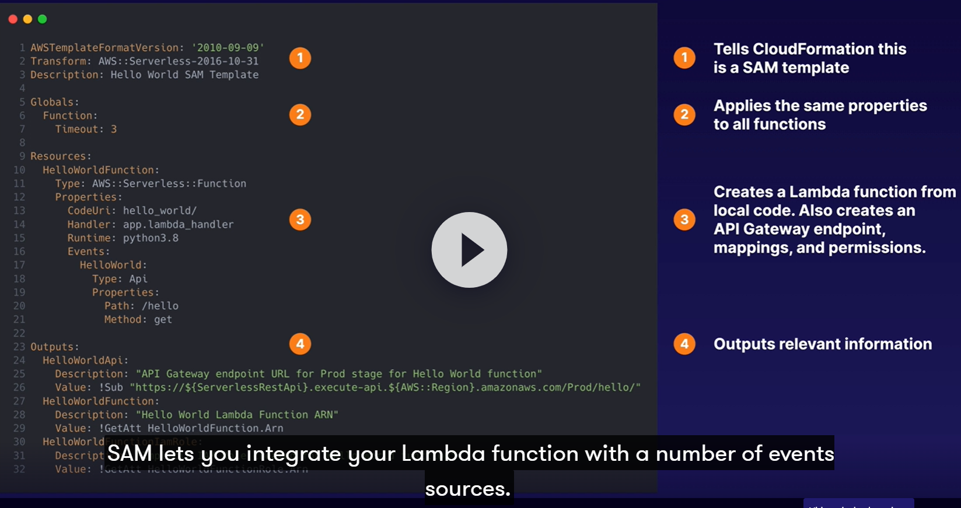

ECS (Elastic Container Service)

1. managed container orchestration service
2. ECS Components
   1. Cluster
      1. Logical collection of ECS resource – either ECS EC2 instances or Fargate instances
   2. Task definition
      1. Defines your application
      2. Similar to Dockerfile but for running containers in ECS
      3. Can contain multiple containers
   3. Container Definition
      1. Inside a task definition, it defines the individual containers a task uses
      2. Controls CPU and memory allocation and port mappings
   4. Task
      1. Single running copy of any containers defined by a task definition
      2. One working copy of an application
   5. Service
      1. Allows task definitions to be scaled by adding tasks
      2. Defines minimum and maximum values
   6. Registry
      1. Storage for container images
      2. Used to download images to create containers

EKS (Elastic Kubernetes Service)

1. Like ECS, supports both EC2 and Fargate
2. Why use EKS?
   1. If you are already using K8s and want to migrate to AWS

ECR

1. Store, manage and deploy images
2. Pay for storage and data transfer

